Outline
- A) 6 CPIC guidelines (high level view)
- Clinical decision support implementer
- B) WGS as input data (69 subjects with whole genome genome sequence)
- C) So what?

Background
- http://www.pharmgkb.org/page.action?key=cpicGeneDrugPairs
- Pharmacogenes: TPMT, CYP2C19, CYP2C9, VKORC1, CYP2D6, HCP5, and SLCO1B1.
- Implementer:
- if <DRUG_ORDER (shortlist)> and <G_DATA> then EXECUTE GUIDELINE
- If <SIGNIFICANT> then <ALERT>

- Actions: 1.change drug, 2.keep the drug and change dose
- “Avoid codeine use due to lack of efficacy. Consider alternative analgesics such
as morphine or a nonopiod”
- Obtain genetic data determine haplotypes (combine into diplotype)
assign “metabolizer type” action (recommendation table)
- Pure implementer site (no own PGx research), not a formal member of PGRN
- Clinical informatics background (implement hypertension guideline, rheumatology, preventive care, drug-drug interactions)

Decision tables (June 2012)
Haplotypes, diplotype, tag allele (tag variant - position that determines the haplotype)

TMPT
Normal 1 Dose 1 Change 1
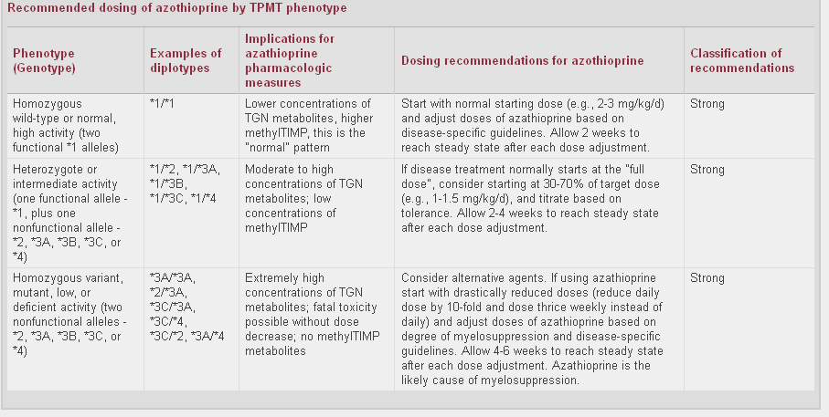

Clopidrogel
Normal 1 Change 2

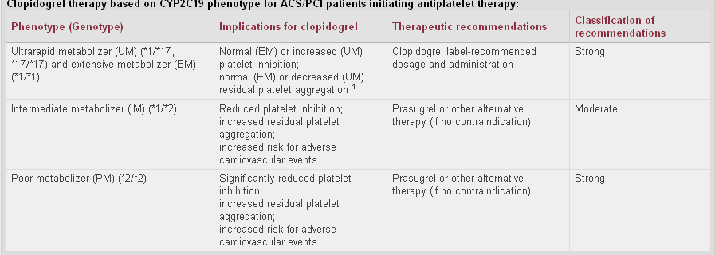

Warfarin
Always adjust dose
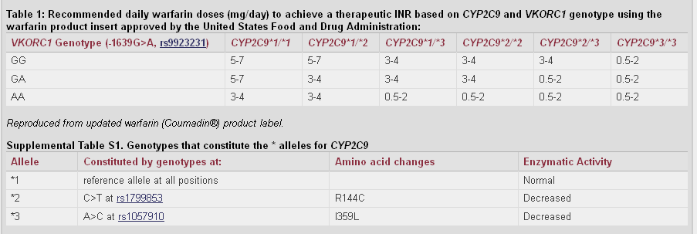

Codeine
Normal 2 Change 2
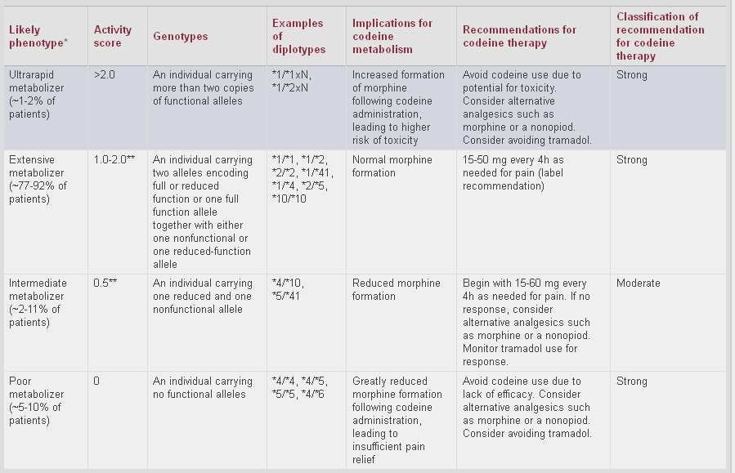

Abacavir
Normal 1 Change 1

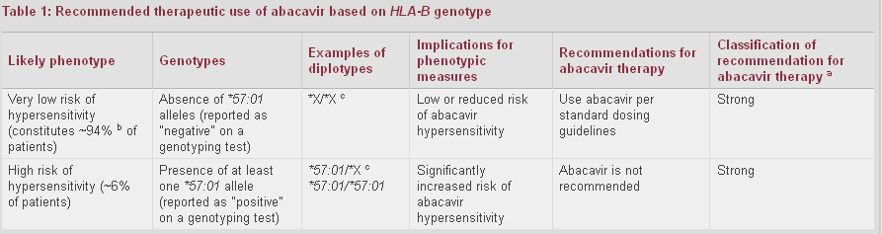

Simvastatin
“ADE prevention guideline”
Kicks in only if dose is 40mg or greater
THEN Normal 1 Dose 1 Change 1

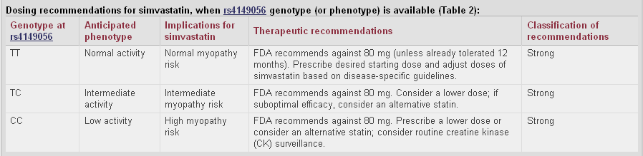

PLUS flowchart
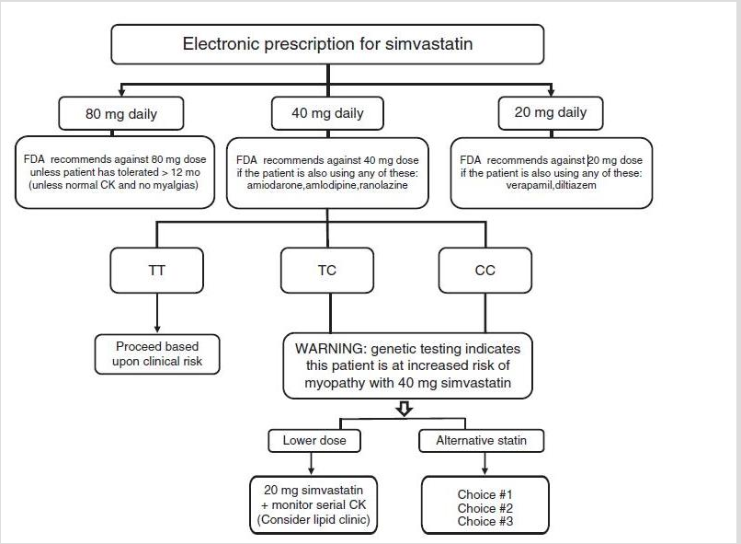

Look up tables (September 2012)
- http://www.pharmgkb.org/page/tppTables

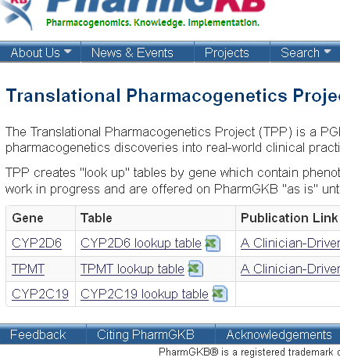

Tag alleles
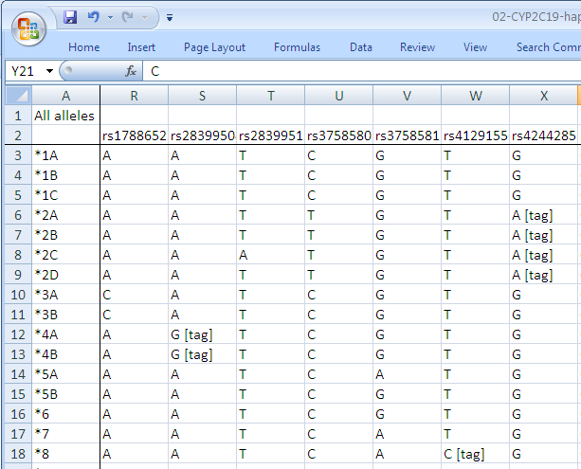

Surprise

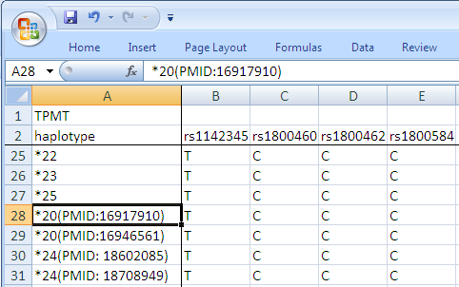

Web vs. CSV file differences, emailed PharmGKB team

Overview table

Drug/drug class | Gene | EntrezGene ID | Chromosome | Strand | PDG: Number of tag variations with clinical recommendations | PGKB: count of haplotypes | PGKB: count of tag alleles | VCF: Count of variants
thipurines | TPMT | 7172 | 6 | -1 | 9 | 29 | 9 | 201
clopidrogel | CYP2C19 | 1557 | 10 | 1 | 2 | 33 | 37 | 1392
warfarin | CYP2C9 | 1559 | 10 | 1 | 3 | 34 | 20 | 481
warfarin | VKORC1 | 79001 | 16 | -1 |  | 13 | 10 | 30
codeine | CYP2D6 | 1565 | 22 | -1 | 9 | 11 | 10 | 242
abacavir | HCP5 | 10866 | 6 | 1 | 1 | 2 | 1 | 1370
simvastatin | SLCO1B1 | 10599 | 12 | 1 | 1 | 34 | 25 | 1021

CPIC guidelines implementation conclusions
- Drug terminology codes
- if <DRUG_ORDER (shortlist)>
- RxNorm codes (or drug classes: NDR-RT or ATC codes)
- CPIC guidelines differ in degree of variability addressed by the guideline
- Address all possible situations given a list of gene positions (tag variants)
- Lookup table
- Highlight and address only specific situations (simvastatin)
- “within the guideline” / “outside the guideline”
- Star notation system
- Curation authority (PharmgKB, cypalleles.ki.se, other?)
- Computable solution
- GetUpdatedHaplotypeTable(‘http://www.pharmgkb.org/download/PA128?data=haplotype&format=csv’)
- Long-term solution for determining haplotypes (in 2015)
- CPIC guidelines are developed with genotyping data in mind

B) WGS as input data
- Variant Call Files (VCF)
- Complete Genomics, 7.8GB (all chromosomes, 69 patients)
- 1000G (70GB, only chromosome 6) (1.1TB)

- Tabix utility to restrict it to 7 genes
- The filtered VCF file sizes ranged from 13kB to 500kB
- Two scenarios
- SIMPLE: VCF data (WGS) genotyping data PGx [dosing] recommendations
- COMPLEX: VCF data (WGS) PGx [dosing] recommendations

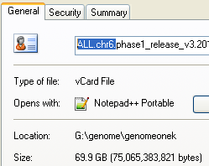

VCF file example
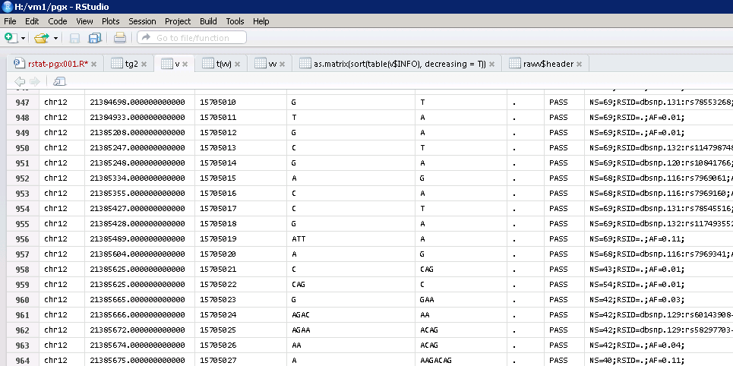

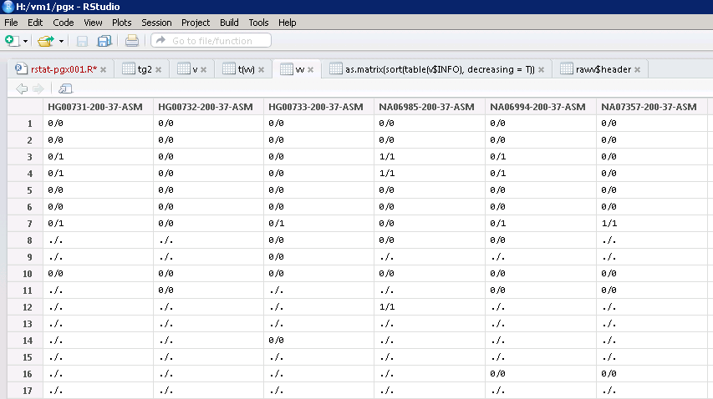

Generating recommendations
- Example: Simvastatin guideline
- Simple scenario: in 16% of patients (11/69): dose alteration (if >40mg simvastatin is being ordered)
- 1 tag variant, all scenarios are covered by the guideline, always “within the guideline”,
16% of patients get a clear message
- Complex scenario: in an average patient, there is 259 (SD:±76) other variations (other than rs4149056)
- of which 58.7 (SD:±10.2) are not present in dbSNP
- 1021 variants, every patient is “outside the guideline”
0% of patients get a clear message

- rare mutations (some of them missense (nonsynonymous))
- frameshift insertions or deletions?
- early stop codon (nonsense mutation)
- There will never be a guideline covering all possibilities (meta-guideline)

WGS as input data – conclusions
- Existing CPIC guidelines were written with genotyping input data in mind
- When WGS data is simplified to emulate genotyping data, CPIC guidelines could be applied
- WGS shows large amount of additional mutations
- some of which cannot be ignored and probably can be
interpreted with current knowledge (e.g., early stop codon)
- WGS is the only method that can see insertions and deletions (unless a custom genotyping array is used)
- We have today 1000+ whole genomes at our institution (policy for incidental findings, cancer domain)

- Potential error:
- genotyping data predicts gain of function of one allele lower dose (rs1234567)
- WGS shows loss of function due to early stop codon due to insertion (10 bp prior rs123467)

So what?
- Pre-requisite fact: dealing with WGS sequencing data is an unsolved problem (outside PGx domain)
- Do you have similar WGS findings? (rare mutations, indels)
- Approach
- (1) Managing combinations of variants (star alleles)
vs.
- (1) managing individual variants and (2) combining pipeline
- Meta CPIC guideline?
- Instead of: genetic data haplotypes/diplotypes “metabolizer type” action
- Interpretation pipeline
- “Inside the guideline”
- Known and well described variants
- General approach to situations “outside the guideline”
- A truly unknown variants (no clear message)
- Predictable biological phenomena with known impact
(synonymous rare mutation)
- What to say to the clinician when genetic variation exists and there is no clear clinical message can be generated
- Implementer’s decision (local) vs. expert concensus (CPIC meta-guideline)

The simvastating PDG does state that other mutations in the pharmacogene impact dosing but does not offer a

Conlusions
- Part A) Lookup tables are important part of a published CPIC guideline (implementers)
- PharmgKB as single source of knowledge (lkup table integration)
- Part B)

