CYP2D6 Phenotype Standardization Project

Background
Reporting of CYP2D6 phenotype based on genotype is not standardized across clinical laboratories or even pharmacogenetics clinical guidelines, such as the CPIC and the Dutch Pharmacogenetics Working Group (DPWG) guidelines. Some laboratories and the DPWG guidelines consider an activity score (AS) of 1.0 (e.g. combination of a normal and no function allele or two decreased function alleles) as a CYP2D6 intermediate metabolizer (IM) while the CPIC guideline categorizes this score as a CYP2D6 normal metabolizer (1-3). Since recommendations are based on phenotype, the assignment of phenotype based on genotype is an important aspect to clinical implementation. Thus, reporting different inferred phenotypes from a genotype across laboratories and guidelines has created substantial confusion and inconsistencies in recommendations. To maximize the utility of pharmacogenetic test results, it is therefore not only desirable, but prime time to standardize translation of genotype into phenotype. The purpose of this project is to determine consensus among CYP2D6 experts as to the definitions used to assign CYP2D6 phenotype based on genotype.
Project Objectives
- Determine a strategy for defining CYP2D6 phenotype based on genotype using a modified Delphi method.
- Standardize phenotype definitions across CPIC and DPWG guideline and external groups.
Methods (see figure below)
Phase 0: We will first send a survey to clinical labs doing CYP2D6 genotyping (identified through the NIH’s Genetic Testing Registry) and ask for which allelic variants they test and their genotype to phenotype translation tables. This will allow us to a) document the problem and b) would give us a starting place on how we should/could proceed

Phase 1/2: Structured discussion via phone conference with all the experts. We would come to this call VERY prepared with examples of why the current systems ARE or ARE NOT appropriate and how other methods might help resolve these issues. Based on these discussions, we will put together a survey to poll the experts on how they think we should proceed. This might take a few rounds to find some common ground. Some solutions might include to reduce the AS of alleles, for example assigning a value of 0.25 to a *10 allele which lead to an IM classification of *10/*10. The discussion should identify which alleles to include and based on what criteria. Another option would be to introduce an additional phenotype group, e.g. slow metabolizers to describe subjects with an AS=0.5 and use the IM label for subjects with an AS=1, etc.

Phase 3/4: Once we have decided on a method we would want to adopt, we will need to refine this via a survey approach (e.g., if introducing an additional AS it needs to be decided if it should be accompanied by the introduction of an additional allele function such as severely decreased function allele and in which phenotype categories newly resulting AS such 0.25, 0.75, 2.25 should be placed). We will continue this process until we have consensus.

Phase 5: Post recommendations for comment (calling this validation stage). Maybe we also send out to genetic testing labs, etc. for feedback.

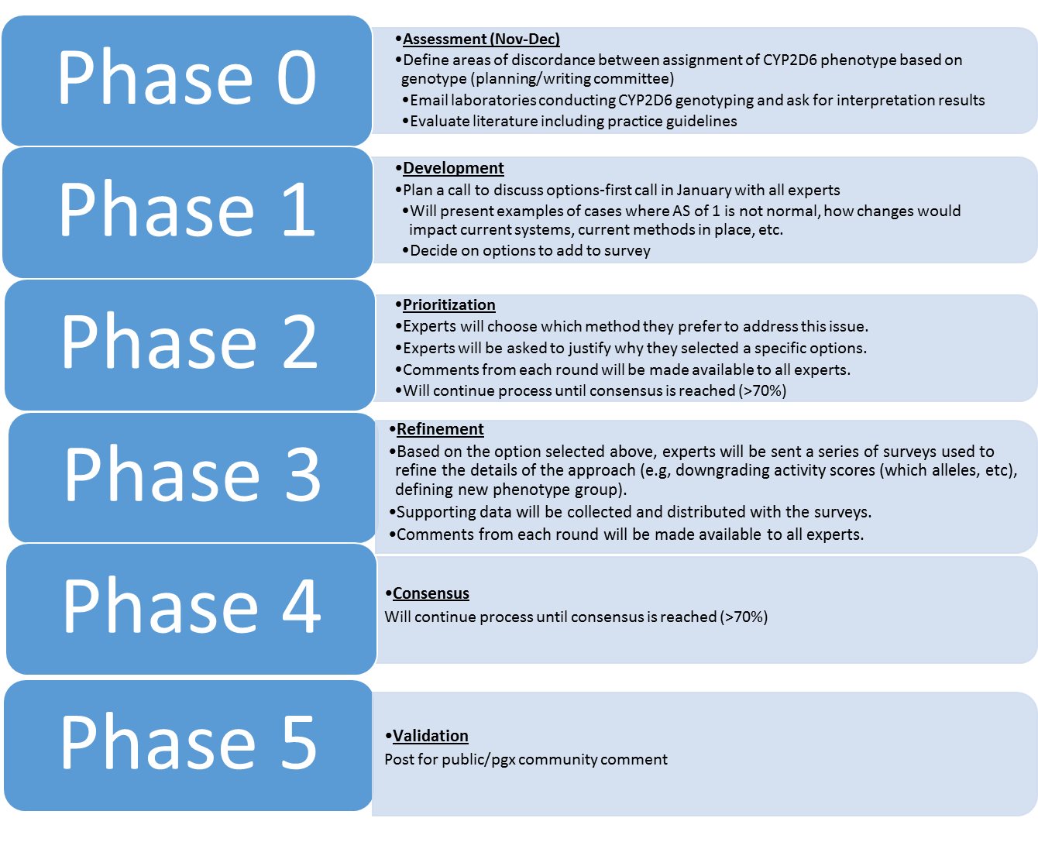

References
(1) AmpliChip™ CYP450 Package Insert. (ed. I, R.D.) (2005).
(2) Crews, K.R. et al. Clinical Pharmacogenetics Implementation Consortium guidelines for cytochrome P450 2D6 genotype and codeine therapy: 2014 update. Clin Pharmacol Ther 95, 376-82 (2014).
(3) Hicks, J.K. et al. Clinical Pharmacogenetics Implementation Consortium (CPIC) Guideline for CYP2D6 and CYP2C19 Genotypes and Dosing of Selective Serotonin Reuptake Inhibitors. Clin Pharmacol Ther 98, 127-34 (2015).

