Standard procedures for writing CPIC guidelines

Table of Contents
Key Points about CPIC guidelines: 2
CPIC Guideline Development Process 3
1. Initial assessment of known gene-drug relationship 3
2. Identification of content experts and formation of writing committee 3
3. Management of Conflicts of Interest 3
4. Review guidelines from professional societies 4
5. Conference call with co-authors and participants 4
6. Evidence review (sub-group of writing committee) 4
7. Finalize a draft of Table 2 7
8. Identify available genetic test and variants tested. 9
9. Draft a Table 1 (genotype to phenotype correlation) 9
10. Write manuscript text 9
11. Construct supplemental data tables about variants and frequencies (see template Appendix B) 10
12. Construct Clinical Decision Support (CDS) workflow figures and translation tables 11
13. Miscellaneous 11
14. Internal review 11
15. After publication accepted 12
16. Guideline updates 12
17. Resources 13
APPENDIX A: Manuscript Template 14
APPENDIX B: Supplemental Material Template 27
APPENDIX C: CPIC Coordinator Checklist 45
Authorship on CPIC guidelines 48
PharmGKB Curation steps 51

Key Points about CPIC guidelines:

- They are based on the assumption that the test results are in hand; they are not to discuss the merits of doing the test

- Their purpose is to give a clear guide for prescribers right now

- Table 2 is the heart of the CPIC guideline and should be written as early as possible in the guideline development process to focus the guideline

- Use standardized formats for diplotypes, phenotypes, drugs, and genes whenever possible to facilitate machine-readable compatibility of content

- The guidelines will be updated as needed to accommodate important new evidence as it emerges

- Comprehensive rather than selective inclusion of variants is preferred: if any clinical test includes the variant, clinicians may be faced with how to use the information

- (Standard) Disclaimer, conflicts, and acknowledgement of grant support must be included (see Authorship on CPIC guidelines)

- Main Manuscript is limited to 3000 words and 40 references but supplement is unlimited in size and references. Standard format must be followed (templates available in Appendix A and B).

- Finished documents are posted and updated on PharmGKB.

- Always at least one co-author from PharmGKB

- The CPIC Steering Committee needs to approve the dosing recommendation (Table 2) and the writing plans for each gene/drug CPIC guideline (see Authorship on CPIC guidelines).

CPIC Guideline Development Process

Initial assessment of known gene-drug relationship

CPIC and the CPIC Steering Committee use a systematic process for prioritization of genes/drugs. CPIC has classified genes/drugs into 4 levels (A, B, C, and D) (see http://www.pharmgkb.org/page/cpicStatusLegend#PrioritizationofCPICGeneDrugPairs):
- CPIC level A guidelines include at least one strong or moderate actionable prescribing recommendation
- CPIC level B guidelines are written for genes/drugs with an optional recommendation
- CPIC level C guidance’s apply to drugs that are linked to CPIC level A or B genes, but for which actions cannot be recommended, as well as to genes that are highly touted to be actionable but for which there is little literature to support an actionable recommendation.
- CPIC level D genes/drugs do not result in CPIC guidelines due to lack of actionability/evidence but are encompassed in PharmGKB clinical annotations process

The list posted on PharmGKB includes: 1) all genes/drugs with PharmGKB Level of Evidence 2B and higher 2) genes/drugs included on the FDA’s Table of Pharmacogenomic Biomarkers in Drug Labeling related to germline variants 3) other genes/drugs nominated by CPIC members. Nominations for new guidelines are discussed on regular, monthly CPIC conference calls and are approved by both CPIC members and the Steering Committee.

Prescribing recommendations will be guided based on principle that genotypes are known: what gene/drug relations are so clear that clinicians should be provided with CPIC guidance when test results are in hand?

Identification of content experts and formation of writing committee

Once a topic has been approved by CPIC members and the Steering Committee, a senior author is identified through self-nomination or by request of the CPIC Steering Committee. The “Authorship on CPIC guidelines” document outlines the responsibilities of the senior author and criteria for authorship on CPIC guidelines.

Management of Conflicts of Interest

All potential authors must complete and sign the CPIC conflicts of interest disclosure form. The “Authorship on CPIC guidelines” document outlines the process for managing conflicts of interest.

Review guidelines from professional societies

- Royal Dutch Pharmacists association (see PharmGKB for tables and link to paper)[PMID 18253145]
- Professional societies, http://guidelines.gov/
- NIH pages
- FDA package insert recommendations http://www.fda.gov/Drugs/ScienceResearch/ResearchAreas/Pharmacogenetics/ucm083378.htm
- Review for recommendations with which you agree, disagree, or find unclear/controversial
- Citations in those guidelines may be useful
- Authors of those guidelines may be interested in joining CPIC guideline, too, or may be willing to review

Conference call with co-authors and participants

The CPIC coordinator will schedule and lead the first guideline conference call.
Items to discuss in first conference call:
- Review of the CPIC SOP.
- Discuss and draft therapeutic recommendations, if any. This does not need to be final, but will help to drive content for the document and to re-evaluate the the CPIC guideline level (A, B, or C).
- Assign sub-group of authors for evidence review (3-4 authors).
- Discuss writing assignments for co-authors (during call/via email).
- Set deadlines for all task assigned.
- Prepare authorship plan and send appropriate signed documents to PharmGKB and to Steering Committee (CPIC coordinator).
  - List of potential authors and affiliations.
  - For each author describe interest/expertise regarding this guideline topic (1-2 sentences or list areas of research or clinical expertise).
  - Timetable for guideline development and writing manuscript.
  - Signed publication MOU (CPIC coordinator will provide)
  - Signed conflicts of interest disclosure (CPIC coordinator will provide)

Evidence review (sub-group of writing committee)

Find the citations that are most important to support your recommendations

These will go into the Evidence Table in the supplement and underlies the key table 2.

Generally a search of PubMed and OVID MEDLINE is done using the following kind of format for your gene and drug of interest. Keywords: (gene name) OR (gene symbol) AND (drug name). Sometimes including a search for the Adverse Drug Reaction (ADR) name may find more specific papers.

Cross-check for papers listed on PharmGKB under the PGx research tab for the drug of interest, where there may be annotations on the papers (must register with PharmGKB to access). This may also aid in capturing all the identifiers (dbSNP rs number, additional common names, etc.) that are used for any variants of interest. Consider using PharmGKB’s publication annotation system.

Make a working document to summarize the evidence

Relevant papers will be annotated using the annotation tools at preview.pharmgkb.org (see curation steps). The PharmGKB author or CPIC coordinator will demonstrate this tool to the evidence review sub-group authors.

The key aspects of the papers should be noted (which variants measured, study size, study type, statistical significance, and key findings). Using the annotated data, the PharmGKB author or CPIC coordinator will create a working document that can be used to score the evidence by the evidence review sub-group.

If the group is large, or the body of evidence is very large, it can be very helpful to put the working document and the supporting papers in a dropbox folder so that all authors/call participants can view it.

Evidence types include
- Randomized trials outcomes with PGx based vs conventional dosing
- Clinical trials demonstrating drug effects linked to functional pharmacogenetic loci
- Preclinical studies demonstrating drug effects linked to functional pharmacogenetic loci
- Case studies associating rare variants and drug effects (e.g. G6PD and rasburicase and DPYD and 5FU)
- In vitro or in vivo evidence that drug A is handled identically to drug B, with strong pharmacogenetic evidence linking the variation to drug B

Note: randomized, controlled trials comparing outcomes with genotype-guided dosing vs conventional dosing will be rare

Score the evidence

Publications supporting a major finding should be grouped together and scored based on all the evidence that supports that major finding using the following criteria:

- High: Evidence includes consistent results from well-designed, well-conducted studies.
- Moderate: Evidence is sufficient to determine effects, but the strength of the evidence is limited by the number, quality, or consistency of the individual studies; generalizability to routine practice; or indirect nature of the evidence.
- Weak: Evidence is insufficient to assess the effects on health outcomes because of limited number or power of studies, important flaws in their design or conduct, gaps in the chain of evidence, or lack of information

This table will form the basis of a table in the supplement, often Table S5:

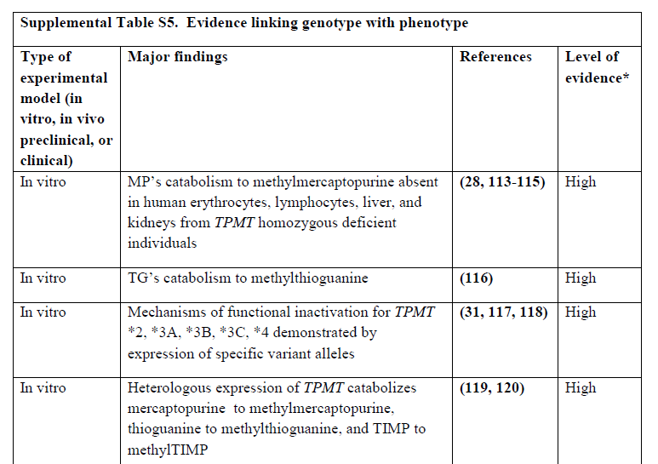

Finalize a draft of Table 2

To assign strength to a prescribing recommendation, CPIC uses a transparent three category system for rating recommendations that was adopted with slight modification from the rating scale for evidence-based recommendations on the use of antiretroviral agents (http://aidsinfo.nih.gov/contentfiles/AdultandAdolescentGL.pdf). Therapeutic recommendations are graded as:
- Strong: “the evidence is high quality and the desirable effects clearly outweigh the undesirable effects”
- Moderate: “there is a close or uncertain balance” as to whether the evidence is high quality and the desirable clearly outweigh the undesirable effects
- Optional: the desirable effects of pharmacogenetic-based dosing are closely balanced with undesirable effects and there is room for differences in opinion as to the need for the recommended course of action.

CPIC recommendations should always include an assessment of its usefulness in pediatric patients.

The phenotype, diplotype, drug, and gene terms in Table 2 should use standardized terminology that facilitates machine-readability and that can be repurposed for other guidelines when possible (e.g., use terms “ultrarapid metabolizer, extensive metabolizer, intermediate metabolizer, and poor metabolizer for all phenotypes to which the terms can apply).

Examples of Table 2:

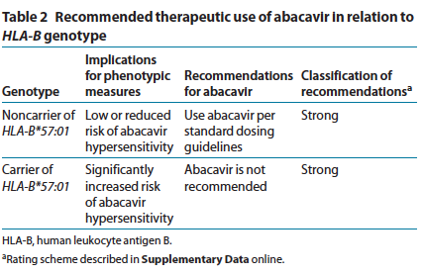

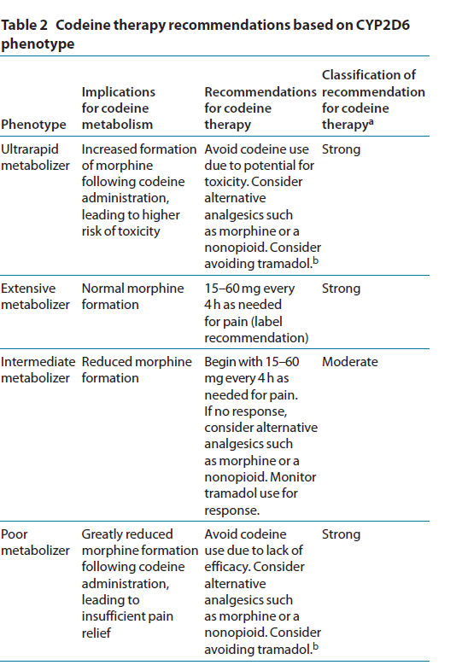

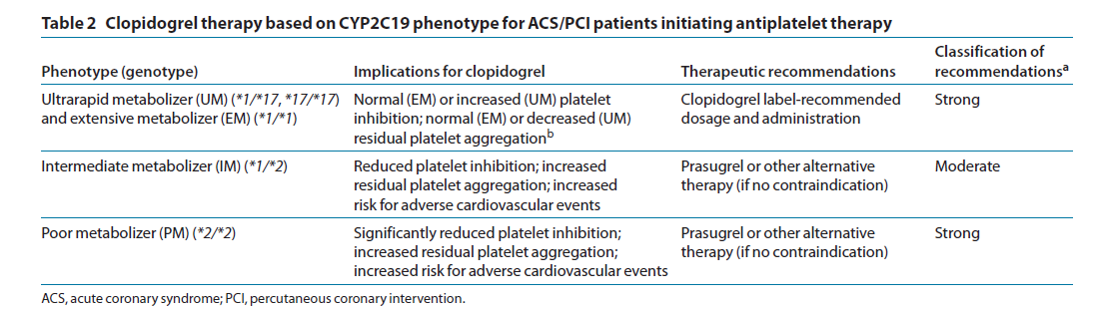

Identify available genetic test and variants tested.

Start with checking the drug/gene pages on PharmGKB.

Check the NIH Gene Test Registry, which will have more tests as it becomes more populated in the future: http://www.ncbi.nlm.nih.gov/gtr/ and search under “Test” tab. The GTR should be listed if the gene is included.

Google search for (gene name) or (gene symbol) and genetic test; also search for (drug name) genetic test, or (ADR/drug name hypersensitivity). This is a little trial and error.

If no one is testing for the variant then it probably doesn’t need to be mentioned in the main guideline; for the supplement, be as comprehensive as is reasonable for defining variants.

Draft a Table 1 (genotype to phenotype correlation)

Is this straightforward or are there alternate interpretations? (e.g., CYP2D6 and different assignment of IM status with different drugs, CYP2A6 and different assignment of metabolizer status with different drugs.) See template for example (Appendix A)

Use standardized terms when possible.

Write manuscript text

All CPIC guidelines adhere to a standard format. Appendix A includes two templates using different formats containing the required content listed below.

Gene:

Background: Include brief background about the gene and its function. If available refer to PharmGKB VIP for more detail.

Genetic Test Interpretation: See template (Appendix A)

Available Genetic Test Options: See template (Appendix A)

Incidental findings: Discuss other associations for the gene/variants. These may be disease associations, unrelated to medication use, not just Pgx associations seen with other drugs.

Other Considerations: Issues critical about the gene that do not easily fit into other sections.

Drug:

Background: Include brief discussion of the drug, if available refer to PharmGKB pathway for more detail. A diagram/figure depicting drug metabolism, transport or mechanism of action may be included in the main text or in the supplement.

Linking genetic variability to variability in drug-related phenotypes: see template (Appendix A)

Dosage Recommendations/Therapeutic Recommendation: Give brief description and rationale for recommendation. (Table 2) (Figure 1; if applicable). All CPIC guidelines (and updates of existing guidelines) should include pediatric recommendations—even if just to acknowledge not enough data are available to make recommendation. Consider listing doses per kg or per m2 if possible.

Recommendations for Incidental Findings: (If applicable)

Other Considerations: Issues critical and related to this section that do not easily fit into other sections.

Potential benefits and risks for the patient

What are the consequences, toxicities or ADRs that may be avoided by PGx dosing? Any risks from incidental findings? Any risks from use of alternative drugs and dosing? (e.g. differences in efficacy? or cost?)

Caveats: appropriate use and/or potential misuse of genetic tests

What are the predictive limitations of test? Are there other variants known to be involved in the phenotype or are there known environmental factors effecting drug response for this drug?

Construct supplemental data tables about variants and frequencies (see template Appendix B)

Sources for mappings of variants to additional names, rs numbers etc. include PharmGKB, HuGE Navigator Variant Name Mapper

Sources for frequencies include published literature scans, specialized variant frequency websites such as that for HLA alleles (www.allelefrequencies.net), Alfred, HapMap etc. PharmGKB staff will help with these tables.

Construct Clinical Decision Support (CDS) workflow figures and translation tables
One author from the guideline writing committee with experience in clinical implementation or clinical expertise in the guideline topic will work with the CPIC informatics working group to create CDS workflow figures and extensive translation tables that link diplotypes for each gene with machine-readable Electronic Health Record (EHS)-ready diplotype-based phenotypes and clinical recommendations, including specific drug prescribing actions and recommendations for the workflow of CDS in any EHR environment (see Appendix B for examples).

Miscellaneous

Populations

Sometimes other guidelines or the preponderance of evidence has been examined in a particular ethnic group, race or population or region. This could be because the variant is in a much higher frequency in a particular group.

The guideline should look firstly at the variant drug relationship irrespective of race/ethnicity.

The issue of race can be discussed but more in the light of how frequency may have influenced the evidence. For example the relationship between HLA-B*15:02 allele and carbamazepine hypersensitivity has been observed more often in Asian populations and the guideline on the FDA label recommends testing only in individuals of Asian descent. However instances have been reported where the allele was present in individuals with hypersensitivity that did not identify in that racial group and were only found after further questioning to have some ancestry. The allele is also associated with risk in non-Asian populations but does not explain all cases suggesting there are additional risk factors.

Disclaimer, conflicts of interest and acknowledgments

Don’t forget to add the disclaimer! And don’t forget grant numbers in acknowledgements and any useful advice that was sought from clinicians that were not involved in the manuscript, etc.

Internal review

Once the manuscript draft has been compiled it should be sent to Teri Klein (teri.klein@stanford.edu), Mary Relling (mary.relling@stjude.org), and Kelly Caudle (kelly.caudle@stjude.org) for review.

After this initial review, the guideline will be posted on the CPIC working group website for at least one week for review by CPIC members. If possible, it will be included in a CPIC teleconference call.

After publication accepted

PubMed Central:
Nature Publishing Group will make immediate (no embargo period) provision of the manuscript to PubMed Central as part of their regular process for the CPIC guidelines published in CPT.
It is the responsibility of the CPIC coordinator to notify the NIH of accepted CPIC guidelines: Chris Kelly (chkelly@ncbi.nlm.nih.gov), Adriana Malheiro (adriana.malheiro@nih.gov), and Wendy Rubinstein (rubinstw@ncbi.nlm.nih.gov).

Genetic Testing Registry:
For each published guideline, PharmGKB will prepare a short structured descriptive summary (“blurb”) for the GTR website. The CPIC coordinator and Mary Relling will review the summary prior to submission to the GTR. The One-Point-of-Contact-with-GTR (OPCG; Michelle Whirl-Carrillo) will coordinate the preparation, review, and submission of GTR summaries.

G2C2:
The GTR summary will also be used for G2C2. The CPIC coordinator will send this to the G2C2 contact.

Guidelines.gov:
The CPIC coordinator will submit each published guideline and guideline update to the National Guideline Clearinghouse (NGC; guidelines.gov).

Corresponding email address:
CPIC guidelines may list one of the authors as the corresponding author, but the CPIC (cpic@pharmgkb.org) email address should be added after the publication has been accepted (i.e. on the galley proof). PharmGKB agrees to forward all relevant correspondence to the corresponding author as they receive it.

Guideline updates

It is the responsibility of PharmGKB to review the content of CPIC guidelines on an ongoing basis (as part of their ongoing literature review), and the guideline should be considered for update whenever new evidence impacts on prescribing recommendations. On an ongoing basis, but at least every 2 years, PharmGKB should document the date last reviewed on the PharmGKB site.

Published guidelines are updated whenever critical new evidence emerges that changes test interpretation or prescribing recommendations.

Senior authors of the prior guideline version will be notified of updates as per the Authorship Plan.
It is the responsibility of the CPIC coordinator to assist with writing and editing updates to CPIC guidelines (Kelly Caudle: kelly.caudle@stjude.org).
There are two types of updates: minor update (change in supplementary material) and major (change in the main manuscript).
Updates of existing guidelines should reflect any changes to guideline format, and should include pediatric recommendations if not originally present.

Resources

List of existing guidelines and those in progress
http://www.pharmgkb.org/cpic/pairs
Booking the conference call line, email Blanca Pineda at bpineda@stanford.edu
(calendar for line is here).

APPENDIX A: Manuscript Template

Clinical Pharmacogenetics Implementation Consortium (CPIC) Guidelines for __________ [gene] and __________ [drug] Dosing

Authors

¹Affiliations

Corresponding Author:
__________________________ cpic@pharmgkb.org

Word counts:
Abstract: (75 limit)
Text: (3,000 limit)
References: (40 limit)
Figures/tables: 3
Keywords: Up to 10

Abstract (75 word limit)

Template 1 (discussion of gene before drug)
Introduction

The purpose of this guideline is to provide information to allow the interpretation of clinical ____ [gene] genotype tests so that the results can be used to guide dosing of _____ [drug/s]. ------------------
Detailed guidelines for use of ______________ as well as analyses of cost effectiveness, are beyond the scope of this document. CPIC guidelines are periodically updated at http://www.pharmgkb.org.
------------------------------.
Focused Literature Review

A systematic literature review focused on ____ genotype and ____ use (details in Supplement) was conducted. Definitive reviews (ref) were relied upon to summarize much of the earlier literature.

Gene: _____
Background

Genetic Test Interpretation
_______ Each named * allele is defined by the genotype at one or more specific SNPs (Supplemental Table S1) and _________ [provide definitive website for alleles] The _____ [functional assay/s] associated with the most common allelic variants is summarized in Supplemental Table S2.
The assignment of the likely _____ [gene] phenotype, based on * allele ___________ diplotypes, is summarized in Table 1. ____ [gene] alleles have been extensively studied in multiple geographically, racially, and ethnically diverse groups (Supplemental Tables S3 and S4). One of the limitations inherent in a genotype-only test is that very rare or de novo variants will not generally be included in any commercially available genotyping test.

Available Genetic Test Options
See Supplementary material and www.PharmGKB.org for more information on commercially available clinical testing options.

Incidental findings
_______ diseases or conditions that have/have not been linked to variation in the ____ [gene] unrelated to medication use. ____________

Other considerations

Drug (s) (Use RxNorm terms whenever possible)

Background._______________

Linking genetic variability to variability in drug-related phenotypes.
There is substantial evidence linking _____ [gene] genotype with phenotypic variability (see Supplemental Table S5). Application of a grading system to evidence linking genotypic to phenotypic variability indicates a high quality of evidence in the majority of cases (Supplemental Table S5). This ___________ plus ___________ provides the basis for most of the dosing recommendations in Table 2.

Dosage Recommendations/Therapeutic Recommendations. __________
(Table 2) Include pediatric recommendations—even if just to acknowledge not enough data are available to make recommendation. Use language that would not prohibit reimbursement or restrict access of the genetic test in this population
(e.g. …, at the time of this writing there are no/sparse data available on this gene’s effects on this drug’s response in pediatric patient populations, although there is no reason to suspect that gene’s polymorphisms will affect this drug’s metabolism differently in children compared to adults).

Recommendations for Incidental Findings._______________

Other considerations.__________________

Potential Benefits and Risks for the Patient
___________________

Caveats: Appropriate Use and/or Potential Misuse of Genetic Tests
________________

Disclaimer
Clinical Pharmacogenetics Implementation Consortium (CPIC) guidelines reflect expert consensus based on clinical evidence and peer-reviewed literature available at the time they are written, and are intended only to assist clinicians in decision-making, as well as to identify questions for further research. New evidence may have emerged since the time a guideline was submitted for publication. Guidelines are limited in scope and are not applicable to interventions or diseases not specifically identified. Guidelines do not account for all individual variation among patients and cannot be considered inclusive of all proper methods of care or exclusive of other treatments. It remains the responsibility of the health care provider to determine the best course of treatment for the patient. Adherence to any guideline is voluntary, with the ultimate determination regarding its application to be solely made by the clinician and the patient. CPIC assumes no responsibility for any injury to persons or damage to property related to any use of CPIC's guidelines, or for any errors or omissions.

Acknowledgement

Conflict of Interest
Include all possible conflicts, including NIH funding, that could be interpreted to indicate that authors are “advocates” of the enclosed recommendations, as well as any sources of revenue from patents, stock ownership, etc. Include spouses/family members in declarations.

REFERENCES

Template 2 (discussion of drug before gene)
Introduction

The purpose of this guideline is to provide information to allow the interpretation of clinical ____ [gene] genotype tests so that the results can be used to guide dosing of _____ [drug/s]. ------------------
Detailed guidelines for use of ______________ as well as analyses of cost effectiveness, are beyond the scope of this document. CPIC guidelines are periodically updated at http://www.pharmgkb.org.
------------------------------.
Focused Literature Review

A systematic literature review focused on ____ genotype and ____ use (details in Supplement) was conducted. Definitive reviews (ref) were relied upon to summarize much of the earlier literature.
Drug (s):

Background._______________

Gene: _____
Background

Genetic Test Interpretation
_______ Each named * allele is defined by the genotype at one or more specific SNPs (Supplemental Table S1) and _________ [provide definitive website for alleles] The _____ [functional assay/s] associated with the most common allelic variants is summarized in Supplemental Table S2.
The assignment of the likely _____ [gene] phenotype, based on * allele ___________ diplotypes, is summarized in Table 1. ____ [gene] alleles have been extensively studied in multiple geographically, racially, and ethnically diverse groups (Supplemental Tables S3 and S4). One of the limitations inherent in a genotype-only test is that very rare or de novo variants will not generally be included in any commercially available genotyping test.

Available Genetic Test Options
See Supplementary material and www.PharmGKB.org for more information on commercially available clinical testing options.

Incidental findings
_______ diseases or conditions that have/have not been linked to variation in the ____ [gene] unrelated to medication use. ____________

Other considerations.

Linking genetic variability to variability in drug-related phenotypes.
There is substantial evidence linking _____ [gene] genotype with phenotypic variability (see Supplemental Table S5). Application of a grading system to evidence linking genotypic to phenotypic variability indicates a high quality of evidence in the majority of cases (Supplemental Table S5). This ___________ plus ___________ provides the basis for most of the dosing recommendations in Table 2.

Dosage Recommendations/Therapeutic Recommendations. __________
(Table 2) Include pediatric recommendations—even if just to acknowledge not enough data are available to make recommendation. Use language that would not prohibit reimbursement or restrict access of the genetic test in this population
(e.g. …, at the time of this writing there are no/sparse data available on this gene’s effects on this drug’s response in pediatric patient populations, although there is no reason to suspect that gene’s polymorphisms will affect this drug’s metabolism differently in children compared to adults).

Recommendations for Incidental Findings._______________

Other considerations.__________________

Potential Benefits and Risks for the Patient
___________________

Caveats: Appropriate Use and/or Potential Misuse of Genetic Tests
________________

Disclaimer
Clinical Pharmacogenetics Implementation Consortium (CPIC) guidelines reflect expert consensus based on clinical evidence and peer-reviewed literature available at the time they are written, and are intended only to assist clinicians in decision-making, as well as to identify questions for further research. New evidence may have emerged since the time a guideline was submitted for publication. Guidelines are limited in scope and are not applicable to interventions or diseases not specifically identified. Guidelines do not account for all individual variation among patients and cannot be considered inclusive of all proper methods of care or exclusive of other treatments. It remains the responsibility of the health care provider to determine the best course of treatment for the patient. Adherence to any guideline is voluntary, with the ultimate determination regarding its application to be solely made by the clinician and the patient. CPIC assumes no responsibility for any injury to persons or damage to property related to any use of CPIC's guidelines, or for any errors or omissions.

Acknowledgement

Conflict of Interest
Include all possible conflicts, including NIH funding, that could be interpreted to indicate that authors are “advocates” of the enclosed recommendations, as well as any sources of revenue from patents, stock ownership, etc. Include spouses/family members in declarations.

REFERENCES

Table 1. Assignment of likely _____ [gene] phenotypes based on genotypes
Likely Phenotype | Genotypes | Examples of diplotypes
Homozygous wild-type or normal, high activity or extensive metabolizer (constitutes ~__% of patients) | An individual carrying 2 or more functional (*1) alleles | *1/*1
Heterozygote or intermediate activity or intermediate metabolizer (~__% of patients) | An individual carrying 1 functional allele (*1) plus one non-functional allele (*2, *___, ___) | *1/*2, *1/*3A, *1/*3B, *1/*3C, *1/*4
Homozygous variant, mutant, low, or deficient activity or poor metabolizer (~ __% of patients) | An individual carrying 2 non-functional alleles (*2, *3A, *___, ___) | *3A/*3A, *2/*3A, *3C/*3A, *3C/*4, *3C/*2, *3A/*4
Ultrarapid…. | Add rows as needed

Table 2. Recommended Dosing of ____ [drug/s] by ____ [gene] phenotype
 | Drug x |  |  | Drug y |  | Drug z
Phenotype | Implications for phenotypic measures | Dosing recommendations for ____ [ drug x] | Classification of recommendations¹ | Dosing recommendations for ____ [ drug y] | Classification of recommendations¹ | Implications for phenotypic measures | Dosing recommendations for ____ [ drug z] | Classification of recommendations¹
Homozygous wild-type or normal, high activity or extensive metabolizer | Lower concentrations of ___ | Start with normal starting dose (e.g. __mg/m²/d or __ mg/kg/d) and adjust doses based on ___ | Strong | Start with normal starting dose (e.g. __mg/m²/d or __ mg/kg/d) and adjust doses based on ___ | Strong | Lower concentrations of ___ | Start with normal starting dose (e.g. __mg/m²/d or __ mg/kg/d) and adjust doses based on ___ | Strong
Heterozygote or intermediate activity or intermediate metabolizer | Moderate to high concentrations of ___ | Start with medium starting dose (e.g. __mg/m²/d or __ mg/kg/d) and adjust doses based on ___ | Strong | Start with medium starting dose (e.g. __mg/m²/d or __ mg/kg/d) and adjust doses based on ___ | Strong | Moderate to high concentrations of ___ | Start with medium starting dose (e.g. __mg/m²/d or __ mg/kg/d) and adjust doses based on ___ | Moderate
Homozygous variant, mutant, low, or deficient activity or poor metabolizer | Extremely high concentrations of ____ | Start with very low dose (e.g. __mg/m²/d or __ mg/kg/d) and adjust doses based on ___ | Strong | Consider alternative agents. | Strong | Extremely high concentrations of ____ | Start with very low dose (e.g. __mg/m²/d or __ mg/kg/d) and adjust doses based on ___ | Strong
- Rating scheme described in Supplement (See Supplemental Table)

Figure 1 (optional) Example

APPENDIX B: Supplemental Material Template

Clinical Pharmacogenetics Implementation Consortium (CPIC) Guidelines for __________ [gene] and __________ [drug] Dosing

Authors

¹Affiliations

Literature Review:
We searched the PubMed database (1966 to and Ovid MEDLINE (1950 to) for keywords _____________________________. Literature evidence for this guideline was annotated, organized, and assessed using PharmGKB web tools (http://www.pharmgkb.org). All papers used as literature evidence for this guideline can be found on the PharmGKB website.
Using the specified search criteria, _ publications were identified after excluding non-English manuscripts or review articles. Inclusion criteria included________________. Following application of the inclusion criteria, __ publications were reviewed and included in the evidence table.

Genetic Test Interpretation
The haplotype, or star (*) allele name, is determined by a specific SNP or a combination of SNPs that are interrogated in the genotyping analysis. The genotypes that constitute the haplotype, or star (*) alleles for _______, and the rs# for each of the specific genomic nucleotide alterations that define the alleles, are described in Supplemental Table S1.
The genotype results are generally reported as a diplotype, which includes one maternal and one paternal star allele (e.g. *1/*___). The _________ [gene function] associated with each of the common * alleles is summarized in Supplemental Table S2. ______________________

Available Genetic Test Options
Commercially available genetic testing options change over time. Below is some information that may assist in evaluating options. _____________________________________. Some laboratories offering clinical testing may be listed: http://www.pharmgkb.org/resources/forScientificUsers/pharmacogenomic_tests.jsp
Furthermore, the Genetic Testing Registry (GTR) provides a central location for voluntary submission of genetic test information by providers and is available at http://www.ncbi.nlm.nih.gov/gtr/.

Levels of Evidence
The evidence summarized in Supplemental Table S5 is graded using a scaled modified slightly from Valdes et al. (1)
High: Evidence includes consistent results from well-designed, well-conducted studies.
Moderate: Evidence is sufficient to determine effects, but the strength of the evidence is limited by the number, quality, or consistency of the individual studies; generalizability to routine practice; or indirect nature of the evidence.
Weak: Evidence is insufficient to assess the effects on health outcomes because of limited number or power of studies, important flaws in their design or conduct, gaps in the chain of evidence, or lack of information

Strength of Recommendations
CPIC’s dosing recommendations are based weighting the evidence from a combination of preclinical functional and clinical data, as well as on some existing disease-specific consensus guidelines (2) (PMID: 21270786). Some of the factors that are taken into account include _________ [choose from the following and add as needed: in vivo clinical outcome for reference drug, in vivo PK/PD for reference drug, in vitro enzyme activity for reference drug, in vitro enzyme activity with probe substrate plus variant type, in vivo clinical outcome with another drug plus variant type, in vivo PK/PD for another drug plus variant type, in vitro enzyme activity with another drug plus variant type, in vitro enzyme activity with probe substrate only, in vivo clinical outcome with another drug only, in vivo PK/PD for another drug only, and in vitro enzyme functional (protein stability or enzyme activity with another drug) only].

Overall, the dosing recommendations are simplified to allow rapid interpretation by clinicians. We chose to use a slight modification of a transparent and simple system for just three categories for recommendations adopted from the rating scale for evidence-based recommendations on the use of retroviral agents (http://aidsinfo.nih.gov/contentfiles/AdultandAdolescentGL.pdf): strong, where “the evidence is high quality and the desirable effects clearly outweigh the undesirable effects”; moderate, in which “there is a close or uncertain balance” as to whether the evidence is high quality and the desirable clearly outweigh the undesirable effects; and optional, in which the desirable effects are closely balanced with undesirable effects and there is room for differences in opinion as to the need for the recommended course of action.

Strong recommendation for the statement
Moderate recommendation for the statement
Optional recommendation for the statement

Resources to Incorporate Pharmacogenetics into an EHR with CDS

The CPIC informatics working group author will work with guideline authors to write this section for each guideline describing the CDS workflow figures and translation tables. See Supplemental Tables S6 through S12 for examples of these figures and tables.

Supplemental Table S1. Genotypes¹ that constitute the * alleles for ______
Allele | Constituted by genotypes at:
*1
*2
*__
*__
*__
*__
1: Bases reported on the positive chromosomal strand from Golden Path. See www.pharmgkb.org for updates on ___ gene alleles and nomenclature

Indicate the RS# (if applicable) and the Wild-type and variant allele value, and map the nomenclature to positive vs negative strand (prefer to map to positive chromosomal strand for all). Provide citations for definitions of * alleles whenever possible.

Supplemental Table S2. Association between allelic variants and _____ [gene function]
Functional Status | Alleles
Functional / normal activity/ wild-type¹ | *1
Non-functional, variant, or mutant / no activity | ___________
Probable Reduced-function / decreased activity (these alleles are very rare and most have shown reduced function in vivo) [customize for each gene] | ________________
Unknown/Unclear/Conflicting data (these alleles have been well described but its functions is unknown (i.e. very little testing has been done) or it is unclear/controversial (conflicting data on function or unclear data on function).
1: an important caveat for all genotyping tests is that the decision to assign an allele a “wild-type” status is based upon a genotyping test that interrogates only the most common and already-proven sites of functional variation. In human DNA, it is always possible that a new, previously undiscovered (and therefore un-interrogated) site of variation may confer loss-of-function in an individual, and thus lead to the rare possibility of a non-functional allele being erroneously called as “wild-type”

Supplemental Table S3. Frequencies of alleles¹ in major race/ethnic groups²
Allele | Caucasian | South American | African | Mexican | Asian | South West Asian
*1
*2
*__
*__
*__
*__
¹Average allele frequencies are based on the actual number of subjects with each allele reported in multiple studies and then grouped according to ² major race/ethnic groups for studies as defined in [link to PharmGKB)](details and references).

Note: Can use race/ethnicity groupings that correspond most closely to terminology reported in literature.

Supplemental Table S4. Evidence linking genotype with phenotype
Type of experimental model (in vitro, in vivo preclinical, or clinical) | Major findings (Group multiple references together if they all support the same evidence (e.g. inactivating coding variants in TPMT result in higher toxicity from thiopurines in patients receiving thioguanine) | References | Level of evidence¹
In vitro | [Add as many rows as needed]
In vivo preclinical
Clinical

¹High: Evidence includes consistent results from well-designed, well-conducted studies.
Moderate: Evidence is sufficient to determine effects, but the strength of the evidence is limited by the number, quality, or consistency of the individual studies; generalizability to routine practice; or indirect nature of the evidence.
Weak: Evidence is insufficient to assess the effects on health outcomes because of limited number or power of studies, important flaws in their design or conduct, gaps in the chain of evidence, or lack of information

Supplemental Table S5. Drug(s) that pertain to this guideline.
Drug or Ingredient | Source | Code Type | Code
Simvastatin | RxNorm | RxCUI | 36567
Simvastatin | DrugBank | Accession Number | DB00641
Simvastatin | ATC | ATC Code | C10AA01
Simvastatin | PharmGKB | PharmGKB ID | PA451363

Supplemental Table S6. Gene(s) that pertain to this guideline
Gene Symbol | Source | Code Type | Code
SLCO1B1 | HGNC | Symbol | SLCO1B1
SLCO1B1 | HGNC | HGNC ID | HGNC10959
SLCO1B1 | NCBI | Gene ID | 10599
SLCO1B1 | Ensembl | Ensembl ID | ENSG00000134538
SLCO1B1 | PharmGKB | PharmGKB ID | PA134865839

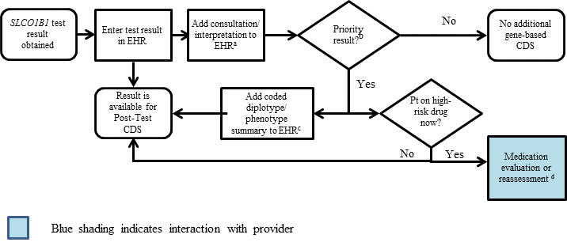

Supplemental Figure S1. SLCO1B1 Pharmacogenetic Test Result: Clinical Implementation Workflow for EHR
ªSee Supplementary Table S9 for diplotype/phenotype specific example
^{b}"Priority result" is defined as a genetic test result that necessitates a change in drug, drug dose, or drug monitoring now or potentially in the future.
^{c}Documentation in the EHR is institution specific. Optimally, the phenotype and/or genotype are available in the EHR to permanently inform prescribing decisions. See Supplementary Table S9 for genotype/phenotype-specific summaries.
^{d}See supplement section “Other Considerations” for discussion regarding use of simvastatin using the information of a patient’s SLCO1B1 genotype test result.
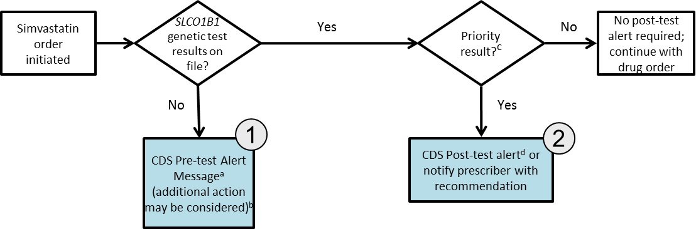
Note: Circled numerals refer to Supplementary Table 12

Supplemental Figure S2. SLCO1B1 Genotype and Simvastatin: Point of Care Clinical Decision Support
ªSee Supplementary Table S10for diplotype/phenotype specific pre-test alert example.
^{b}Additional actions may include ordering a pharmacogenetic test, preventing the clinician from ordering the medication or allowing the clinician to cancel out of the alert.
^{c}Priority result defined as a genetic test result that results in a change in drug, drug dose, or drug monitoring.
^{d}See Supplementary Table S10 for diplotype/phenotype specific post-test alert example.

Supplemental Table S7. Translation of Genotype Test Result into Interpreted Phenotypeª
Phenotype | Genotype definition | Examples of diplotypes | Genotype at rs4149056
Normal function  Homozygous wild-type or normal (55-88% of patients) | An individual carrying two normal function alleles | *1a/*1a, *1a/*1b, *1b/*1b | TT
Intermediate function  Heterozygous (11-36% of patients) | An individual carrying one normal function allele plus one decreased function allele | *1a/*5, *1a/*15, *1a/*17, *1b/*5, *1b/*15, *1b/*17 | TC
Low function  Homozygous variant or mutant (0-6% of patients) | An individual carrying two decreased function alleles | *5/*5, *5/*15, *5/*17, *15/*15, *15/*17, *17/*17 | CC
ªThis table corresponds to the recommendations in the CPIC guideline manuscript

Translation table:
Supplemental Table S8. Example Implementation of this Guideline: Pharmacogenetic Diplotype/Phenotype Summary Entriesª
Diplotype Test Result for SLCO1B1 | Coded Diplotype/Phenotype Summary^{b} | EHR Priority Result Notation^{c} | Consultation (Interpretation) Text Provided with Test Result^{d}
*1a/*1a | None | Normal/Routine/  Low Risk | This result signifies that the patient has two copies of a wild type (normal function) allele. Based on the genotype result, this patient is predicted to have normal SLCO1B1 function. This means that there is no reason to adjust the dose of most medications that are affected by SLCO1B1 (including simvastatin) on the basis of SLCO1B1 genetic status. Please consult a clinical pharmacist for more specific information about how SLCO1B1 function influences drug dosing.
*1b/*1b | None | Normal/Routine/  Low Risk | This result signifies that the patient has two copies of a wild type (normal function) allele. Based on the genotype result, this patient is predicted to have normal SLCO1B1 function. This means that there is no reason to adjust the dose of most medications that are affected by SLCO1B1 (including simvastatin) on the basis of SLCO1B1 genetic status. Please consult a clinical pharmacist for more specific information about how SLCO1B1 function influences drug dosing.
*1a/*1b | None | Normal/Routine/  Low Risk | This result signifies that the patient has two copies of a wild type (normal function) allele. Based on the genotype result, this patient is predicted to have normal SLCO1B1 function. This means that there is no reason to adjust the dose of most medications that are affected by SLCO1B1 (including simvastatin) on the basis of SLCO1B1 genetic status. Please consult a clinical pharmacist for more specific information about how SLCO1B1 function influences drug dosing.
*1a/*5 | SLCO1B1 - Intermediate Function | Abnormal/Priority/  High Risk | This result signifies that the patient has one copy of a wild type (normal function) allele (*1a) and one copy of a decreased function allele (*5). Based on the genotype result, this patient is predicted to have intermediate SLCO1B1 function. This patient may be at risk for an adverse response to medications that are affected by SLCO1B1. To avoid an untoward drug response, dose adjustments may be necessary for medications affected by SLCO1B1. If simvastatin is prescribed to a patient with intermediate SLCO1B1 function, there is an increased risk for developing simvastatin-associated myopathy; such patients may need a lower starting dose of simvastatin or an alternate statin agent. Please consult a clinical pharmacist for more specific information about how SLCO1B1 function influences drug dosing.
*1a/*15 | SLCO1B1 - Intermediate Function | Abnormal/Priority/High Risk | This result signifies that the patient has one copy of a wild type (normal function) allele (*1a) and one copy of a decreased function allele (*15). Based on the genotype result, this patient is predicted to have intermediate SLCO1B1 function. This patient may be at risk for an adverse response to medications that are affected by SLCO1B1. If simvastatin is prescribed to a patient with intermediate SLCO1B1 function, there is an increased risk for developing simvastatin-associated myopathy; such patients may need a lower starting dose of simvastatin or an alternate statin agent. Please consult a clinical pharmacist for more specific information about how SLCO1B1 function influences drug dosing.
*1a/*17 | SLCO1B1 - Intermediate Function | Abnormal/Priority/High Risk | This result signifies that the patient has one copy of a wild type (normal function) allele (*1a) and one copy of a decreased function allele (*17). Based on the genotype result, this patient is predicted to have intermediate SLCO1B1 function. This patient may be at risk for an adverse response to medications that are affected by SLCO1B1. If simvastatin is prescribed to a patient with intermediate SLCO1B1 function, there is an increased risk for developing simvastatin-associated myopathy; such patients may need a lower starting dose of simvastatin or an alternate statin agent. Please consult a clinical pharmacist for more specific information about how SLCO1B1 function influences drug dosing.
*1b/*5 | SLCO1B1 - Intermediate Function | Abnormal/Priority/High Risk | This result signifies that the patient has one copy of a wild type (normal function) allele (*1b) and one copy of a decreased function allele (*5). Based on the genotype result, this patient is predicted to have intermediate SLCO1B1 function. This patient may be at risk for an adverse response to medications that are affected by SLCO1B1. If simvastatin is prescribed to a patient with intermediate SLCO1B1 function, there is an increased risk for developing simvastatin-associated myopathy; such patients may need a lower starting dose of simvastatin or an alternate statin agent. Please consult a clinical pharmacist for more specific information about how SLCO1B1 function influences drug dosing.
*1b/*15 | SLCO1B1 - Intermediate Function | Abnormal/Priority/High Risk | This result signifies that the patient has one copy of a wild type (normal function) allele (*1b) and one copy of a decreased function allele (*15). Based on the genotype result, this patient is predicted to have intermediate SLCO1B1 function. This patient may be at risk for an adverse response to medications that are affected by SLCO1B1. If simvastatin is prescribed to a patient with intermediate SLCO1B1 function, there is an increased risk for developing simvastatin-associated myopathy; such patients may need a lower starting dose of simvastatin or an alternate statin agent. Please consult a clinical pharmacist for more specific information about how SLCO1B1 function influences drug dosing.
*1b/*17 | SLCO1B1 - Intermediate Function | Abnormal/Priority/High Risk | This result signifies that the patient has one copy of a wild type (normal function) allele (*1b) and one copy of a decreased function allele (*17). Based on the genotype result, this patient is predicted to have intermediate SLCO1B1 function. This patient may be at risk for an adverse response to medications that are affected by SLCO1B1. If simvastatin is prescribed to a patient with intermediate SLCO1B1 function, there is an increased risk for developing simvastatin-associated myopathy; such patients may need a lower starting dose of simvastatin or an alternate statin agent and creatine kinase levels may need to be monitored routinely. Please consult a clinical pharmacist for more specific information about how SLCO1B1 function influences drug dosing.
*5/*5 | SLCO1B1 - Low Function | Abnormal/Priority/High Risk | This result signifies that the patient has two copies of a decreased function allele. Based on the genotype result, this patient is predicted to have low SLCO1B1 function. This patient may be at a high risk for an adverse response to medications that are affected by SLCO1B1. If simvastatin is prescribed to a patient with low SLCO1B1 function, there is a high risk of developing simvastatin-associated myopathy; such patients may need a lower starting dose of simvastatin or an alternate statin agent, and creatine kinase levels may need to be monitored routinely. Please consult a clinical pharmacist for more specific information about how SLCO1B1 function influences drug dosing.
*5/*15 | SLCO1B1 - Low Function | Abnormal/Priority/High Risk
*5/*17 | SLCO1B1 - Low Function | Abnormal/Priority/High Risk
*15/*15 | SLCO1B1 - Low Function | Abnormal/Priority/High Risk
*15/*17 | SLCO1B1 - Low Function | Abnormal/Priority/High Risk
*17/*17 | SLCO1B1 - Low Function | Abnormal/Priority/High Risk

This table is provided to show examples of how a test result could be translated into discrete fields within an EHR, including a brief interpretation that summarized the result. The information presented here is consistent with the guideline but may need to be adapted to a given EHR's design and capabilities. Various EHRs or organizations may require different terms, and so different options are provided.
ªA more comprehensive table of genotype/phenotype EHR entries for possible diplotype combinations of all variants listed in Supplemental Table S2 is available at PharmGKB. Definition of alleles should correspond to that in Supplemental Table 1.
^{b}The coded diplotype/phenotype summary is used to store an interpretation of the test result. This is a design decision that may differ among sites.
^{c}For this example, a priority result is defined as a genetic test result that results in a change in drug, drug dose, or drug monitoring.
^{d}The specific wording of the interpretive text may differ among sites.

Supplemental Table S9. Example Implementation of this Guideline: Point of Care Clinical Decision Support
Flow Chart Reference Point  (See Supplemental Figure S3) | CDS Context, Relative to Genetic Testing | Trigger Condition | CDS Alert Textª
1 | Pre-Test | No SLCO1B1 result on file | SLCO1B1 diplotype may be important for simvastatin side effects. An SLCO1B1 genotype does not appear to have been ordered for this patient. Use of an alternative statin or dose may be recommended. Please consult a clinical pharmacist^{b} for more information.
2 | Post-Test | SLCO1B1 - Intermediate Function | Based on the genotype result, this patient is predicted to have intermediate SLCO1B1 function and may be at increased risk for developing simvastatin-associated myopathy. Consider starting with a lower dose of simvastatin (20 mg/day for adults) or choosing an alternate statin agent. Monitor creatine kinase levels routinely. Please consult a clinical pharmacist^{b} for more information.
2 | Post-Test | SLCO1B1 – Low Function | Based on the genotype result, this patient is predicted to have low SLCO1B1 function and may be at high risk for developing simvastatin-associated myopathy. Consider starting with a lower dose of simvastatin (20 mg/day for adults) or choosing an alternate statin agent. Monitor creatine kinase levels routinely. Please consult a clinical pharmacist^{b} for more information.
ªThe specific wording of the alert text may differ among sites.
^{b}Pharmacist, pharmacologist, or a clinician with pharmacogenetic expertise/training

Other Supplemental figures and tables

References

APPENDIX C: CPIC Coordinator Checklist

Manuscript Preparation:

- Complete applicable steps described in SOP for writing a CPIC guideline.
- Phone conference with co-authors.
  - Review CPIC SOP
  - Authorship Plan
- Send a brief authorship plan, conflicts, and draft Table 2 and suggested time frame to the CPIC Steering Committee (mary.relling@stjude.org) for approval.
- Evidence Review completed by sub-group of writing committee
- Ensure draft Table 2 is finalized
- Write manuscript using the templates (Appendix A and B), merge all pieces together into first manuscript draft of guidelines.
- Send to co-authors for review of draft (set a deadline).
- Send to Teri Klein (teri.klein@stanford.edu) and Mary Relling (mary.relling@stjude.org) for internal review.
- Send final draft to co-authors for review.

Submission of Manuscript:

- CPIC guidelines may list one of the authors as the corresponding author, but the CPIC email address (cpic@pharmgkb.org) should be added. (PharmGKB will forward all relevant correspondence to the corresponding author as they receive it.)
- Confirm that manuscript meets all formatting criteria for CPT (some differ than that outlined on CPT website):
  - Word count: Abstract (75 limit); Text (3,000 limit); References (40 limit); Figures/table (3 limit); keywords (up to 10)
  - Double-spaced
  - Pages numbered
  - Title page includes: (a) the complete manuscript title; (b) all authors’ names and affiliations; and (c) the name and address for correspondence, fax number, telephone number, and e-mail address; (d) the number of references, figures, and tables; and key words.
  - Double-check references for accuracy in format (see CPT author guidelines for format)
  - Confirm manuscript contains:
    - Disclaimer
    - Conflicts of Interest
- Submit Manuscript with appropriate cover letter

After Publication (CPIC Coordinator)

- Notify the NIH of accepted CPIC guidelines: Chris Kelly (chkelly@ncbi.nlm.nih.gov), Adriana Malheiro (adriana.malheiro@nih.gov), and Wendy Rubinstein (rubinstw@ncbi.nlm.nih.gov)
- PharmGKB prepares “blurb” of published guideline for GTR.
- CPIC coordinator and Mary Relling review “blurb” prior to submission to GTR.
- Send summary prepared for GTR to G2C2Submit guideline (or updated guideline) to guidelines.gov.
- Ensure that CPIC guidelines are indexed as “Practice Guideline” in PubMed.
- Check for updates on PharmGKB at least every 2 years; coordinate updates of publication as needed.

(1) Valdes, R., Payne, D.A. & Linder, M.W. Laboratory analysis and application of pharmacogenetics to clinical practice. The National Academy of Clinical Biochemistry (NACB) - Laboratory Medicine Practice Guidelines 2010.
(2) Relling, M.V. & Klein, T.E. CPIC: Clinical Pharmacogenetics Implementation Consortium of the Pharmacogenomics Research Network. Clin Pharmacol Ther 89, 464-7 (2011).

Authorship on CPIC guidelines

1. The CPIC Steering Committee will approve plans for each new gene/drug CPIC
guideline.

2. All authors must meet the criteria for authorship and adhere to the standards of Clinical Pharmacology and Therapeutics, and as outlined by ICMJE's Uniform Requirements for Manuscripts Submitted to Biomedical Journals.

3. All authors should declare all interests and activities potentially resulting in conflict of interest (COI) by written disclosure to the CPIC Steering Committee and writing committee before the approval of the authorship plan. Include all possible conflicts, including NIH funding, that could be interpreted to indicate that authors are “advocates” of the enclosed recommendations, as well as any sources of revenue from patents, stock ownership, etc. Include spouses/family members in declarations. All COIs will be reported in guideline manuscript. Each author with an established or possible COI should explain how their relationship(s) could influence the guideline development process or specific recommendations. The CPIC Steering Committee will be guided by the principles that (a) COIs must be transparent to all authors and readers (b) the majority of the authorship team should not have financial COIs (c) it is expected that CPIC guidelines will often have authors who are advocates for using test information to inform prescribing (d) COIs due to employment by an entity in clear conflict will be considered problematic (e) COIs involving senior and first authors are more problematic than those involving middle authors. Before submission for publication, each guideline will be reviewed by a CPIC member without any conflicts to evaluate the language, tone, and conclusions of the recommendation in light of the author(s)’ conflicts.

4. A group of authors, or writing committee, should be established; the senior author, working with the CPIC Steering committee, will agree upon a plan for and the initial composition of the writing committee. Authors can be added later in the process with the approval of the senior author and of the CPIC Steering Committee.

5. Authors must agree to the MOU for CPIC authorship.

6. Authors should meet deadlines and comply with CPIC guideline templates to be considered for future CPIC guideline authorship.

7. Senior authors

a. Senior authors must be approved by the CPIC Steering Committee.

b. A senior author should begin with a draft of Table 2, to identify whether it is likely there will be consensus on prescribing recommendations.

c. It is preferred that senior authors be self-identified and be leaders in the content area addressed by the guidelines. If no senior author self-identifies, the CPIC Steering Committee will identify a suitable author to take lead responsibility for completing the guideline.

d. The senior author is responsible for completing the CPIC guideline based on a mutually-agreed upon schedule, and according to CPIC templates for the main and supplementary manuscripts, agreed to in writing by the CPIC Steering Committee. The senior author may elect to delegate this responsibility to the CPIC Coordinator or the PharmGKB team member for the guideline.

f. Generally, an individual should not lead more than one guideline writing group at a time, although the CPIC Steering Committee can designate exceptions if appropriate.

8. The writing committee should be multidisciplinary, comprising a variety of scientists and clinicians, usually with a maximum of 8-10 authors. Authors should have a track record of publication or expertise in the specific topic area of the guideline. Senior authors can of course include a less experienced trainee as a member of the writing committee, with the understanding that they are mentoring the trainee and supervising their participation. Other exceptions regarding content expertise of the authors should be approved by the senior author and by the CPIC Steering Committee. Desirable characteristics for authorship include involvement of leaders in the specific CPIC topic that will lend credibility to the prescribing recommendations; international representation; evidence of prior publications relevant to the gene, drug, disease state; expertise in clinical pharmacogenetics; adequate representation of senior individuals; and inclusion limited to those with an identified authorship role. For those who have been guideline authors previously, past responsiveness and adherence to CPIC guideline procedures will also be considered.

9. PharmGKB will have at least one of their team members assigned to each CPIC
guideline writing group. The PharmGKB team member will take primary
responsibility for completing Supplementary Tables S1 (Genotypes that constitute the
* alleles or haplotypes, if applicable), for Table S3 (Frequencies of alleles in major race/ethnic groups), Table S4 detailed table on allele frequencies by citation, and the link to the GTR or other genetic tests.

10. CPIC guidelines may list one of the authors as the corresponding author, but their email address should be changed to cpic@pharmgkb.org after the publication has been accepted (i.e. on the galley proof). PharmGKB agrees to forward all relevant correspondence to the corresponding author as they receive it.

11. The CPIC Coordinator should review all guidelines for compliance with templates and SOPs, and should be a co-author if their contributions meet standards for the applicable journal (e.g., Clinical Pharmacology and Therapeutics).

12. CPIC guidelines are expected to be reviewed for updates continually. Authors will be contacted at the time of any proposed updates to PharmGKB or for an updated published guideline. Authorship for updates to published guidelines will be treated with the same considerations as for new guidelines. The senior author of the original guideline will be contacted about plans for the update, and the CPIC coordinator will work with the original guideline senior author to identify the senior author for the update (who may or may not be the senior author for the original guideline) and to develop a new authorship plan. The CPIC Steering Committee must approve authorship plans as for a new guideline. Authors on the original guideline will not necessarily be invited to participate in the update. Additionally, the senior author is encouraged to consider whether there are additional authors they might wish to include as part of the update, particularly in response to new evidence or new practices that have emerged or taken on new prominence since the original guideline.

PharmGKB Curation steps

- Go to preview.pharmgkb.org.

- Sign in (upper right hand corner). (This step assumes you already have a PharmGKB account with appropriate permissions.)

- Go to “My PharmGKB” (in blue header), then click “My PharmGKB” in the drop-down box.

- Under “Annotation Tools”, and “Find literature by PMID” enter in the PMID you wish to annotate on. Click “Go”.

- On the page for that PMID, under the “Variant Annotations” header, click the “+ add” button on the far right.

- In the blue box that says “New”, enter in the rsID for the variant you are annotation (e.g. rs776746).
  - The first option (“the variant affects a phenotype…”) is typically used if you want to add information from a paper about increased risk for a certain phenotype. For example, an increased risk of organ rejection for the rs776746 CC genotype. However, this webform allows you to input any kind of phenotype, e.g., you can input something like “CC is associated with an increased risk of organ rejection” OR you can input something like “CC is associated with increased clearance”. For the latter one though, you can use the second option instead…
  - The second option (“the variant affects a drug dose, response, metabolism…”) is typically used if you want to add information about pharmacokinetic parameters. For example, increased metabolism for the rs776746 CC genotype. It can also be used if the paper discusses response to a drug. For example, an increased response to tacrolimus for the rs776746 CC genotype, as shown by greater remission rates of ulcerative colitis.
  - The third option is used for functional assays.
  - For haplotypes or * alleles: Enter in the gene that contains the haplotype or * allele, instead of an rsID. Instead of selecting genotypes in the webform, you will select haplotypes or * alleles. Other than that, the annotation is the same.
  - You can also “Copy” a variant annotation. This means all the information from a variant annotation, including study parameters, will be copied to a new variant annotation. The new variant annotation can be on the same or different rsID or haplotype. See the information at the end of this guide on how to copy an annotation.

- Once you have selected a choice, click “Continue”.

- When filling in the variant annotation form:
  - The form only allows you to fill in alleles on the + chromosomal strand associated with that variant, as sourced from dbSNP. For instance, some studies discuss rs776746 A and G alleles, but the form will only allow you to use C and T. Additionally, genotypes must be entered in a certain order - the drop-down box to the right of the “Allele/Genotype” box will show you the options.
  - More than one drug can be entered.
  - Tacrolimus studies will mainly deal with transplant patients. The type of transplantation (e.g. kidney transplantation, lung transplantation) should be entered into the “Pop. Phenotype” box.
  - Note on “phenotype” boxes – when entering a phenotype, you can select what “type” of phenotype it is from the drop-down box on the right. For instance, Stevens-Johnson Syndrome could be a “disease” phenotype. Decreased hospital stay could be an “efficacy” phenotype. However, be aware that if you select “disease” here, the disease you enter MUST be in the PharmGKB disease vocabulary (as sourced from MeSH), otherwise you cannot submit the annotation. Sometimes, the tool will change it to the proper MeSH term for you (e.g. if you enter “acute lymphoblastic leukemia” the tool will change it to “precursor cell lymphoblastic leukemia-lymphoma”). If not, you can search for your disease or phenotype in the search bar in the top right corner on any PharmGKB page. The disease may exist in the vocabulary under a different term. If it doesn’t, select an alternative option to “disease”, such as “other”.

However, many phenotypes actually have a disease entry on PharmGKB – for instance, “Kidney Transplantation” is a disease, as is “Lung Transplantation”. Please check if a phenotype has a disease entry first, and if it does, choose “disease” as the phenotype type. Doing this means that you populate the PharmGKB pages for various diseases with the variant annotation information, which is helpful for the knowledgebase. Every disease/phenotype in the PharmGKB vocabulary has its own page; diseases/phenotypes that are not in the vocabulary do not have PharmGKB pages.

For instance, if we look at the webform for the rs776746 metabolism annotation on PMID 21094796 (our example in the meeting) you could have filled in the “pop. phenotype” box with “diseases requiring kidney transplantation”, then selected “other” as the type of phenotype, instead of entering “kidney transplantation” and selecting “disease”. However, “Kidney Transplantation” is a disease on PharmGKB, and has its own page. By entering that instead, you populate the PharmGKB page for kidney transplantation (https://curation.pharmgkb.org/disease/PA165817016) with information from that annotation. That is helpful for PharmGKB and other users.

- When done, click “Submit Variant Annotation”.

- Once you are back on the page for the PMID, you should see your variant annotation. In the far right corner of the annotation, under “Edit”, click the “+sp” box.
  - The pencil allows you to edit your annotation. The red “x” deletes the annotation. The blue check option isn’t relevant for these annotations.

- On the study parameters page, fill out all the information you can, then click “Submit”.
  - The “Population Characteristics” box is for adding other information from the study you think is important. For example, you can select “Drug” from the drop-down box, then fill in that patients also received mycophenolic acid and steroids. Or select “Gender” and write that 80% patients were male.

- The variant annotation is completed. You can repeat this process for different findings. For example, you would do one variant annotation that discusses the association between rs776746 and metabolism, and another discussing the association between rs776746 and transplanted organ rejection.

---

Copying a variant annotation:

- Open the webform by clicking the pencil next to the variant annotation you want to copy.

- Once it’s open, look at the URL - copy the digits after “?variantAnnotationId=” (highlighted in purple below)

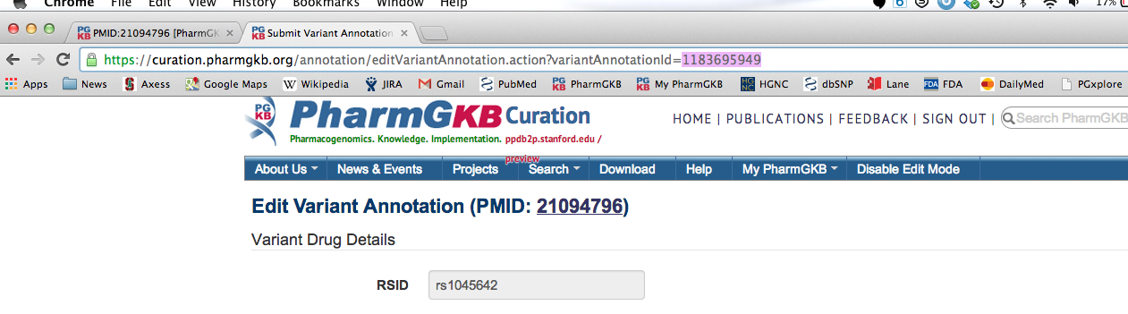

3) Go back to the main PMID page. Click “+ add” to add a new variant annotation.

4) In the blue box on the right that says “Copy Existing Annotation”, paste the variant annotation ID digits into the top box. Then write in the rsID or gene (for haplotypes) that you want to make an identical annotation for.

5) Click the blue “Continue” at the bottom left side.

6) You now have the variant annotation copied. Keep in mind that the alleles, genotypes or haplotypes will have copied over as well, and these may not be right alleles, genotypes or haplotypes for your new rsID or haplotype. You will have to change them, and the tool will throw an error if you try to submit on these incorrect alleles. Once you have made any changes you want, click “Submit”. Your study parameters will also have copied over, so make any changes you want to these as well.

