CYP2D6 Phenotype Standardization Project
Clinical Pharmacogenetics Implementation Consortium (CPIC)

Background
Reporting of CYP2D6 phenotype based on genotype is not standardized across clinical laboratories and even in pharmacogenetics clinical guidelines, such as the CPIC and the Dutch Pharmacogenetics Working Group (DPWG) guidelines. Some laboratories and the DPWG guidelines consider an activity score (AS) of 1.0 (e.g. combination of a normal and no function allele or two decreased function alleles) as a CYP2D6 intermediate metabolizer, while the other clinical laboratories and the CPIC guidelines categorize this score as an CYP2D6 normal metabolizer (1-3). Since recommendations are based on phenotype, the assignment of phenotype based on genotype is an important aspect to clinical implementation and reporting of different inferred phenotypes across laboratories and guidelines has created considerable confusion and inconsistencies in recommendations. To maximize the utility of pharmacogenetic test results, it is desirable to standardize the phenotype prediction from genotype data. The purpose of this project is to determine consensus among CYP2D6 experts as to the definitions used to assign CYP2D6 phenotype based on genotype.
Project Objectives
- Determine a strategy for defining CYP2D6 phenotype based on genotype using a modified Delphi method.
- Standardize this definition in CPIC and DPWG guidelines and test reporting by external groups.
Methods (see figure below)
Phase 0: We will first send a survey to clinical labs doing CYP2D6 genotyping (identified through the NIH’s Genetic Testing Registry) and ask for which allelic variants they test and their genotype to phenotype tables. This will allow us to a) document the problem and b) would give us a starting place on how we should/could proceed

Phase 1/2: Structured discussion via phone conference with all the experts. We would come to this call VERY prepared with examples of why the current systems ARE or ARE NOT appropriate and how other methods might help resolve these issues. Based on these discussions, we would be put together a survey to poll the experts on how they think we should proceed. This might take a few rounds to find some common ground. Some basic solutions include downgrading some of the alleles, making an AS of 1 a IM (so an IM would be a AS of 0.5 to 1), adding an additional phenotype group, etc.

Phase 3/4: Once we have decided a method we would want to adopt, we will need to refine the approach via a survey approach (e.g., if downgrading alleles, we will need to decide which ones and have good justification for this, etc.). We will continue this process until we have consensus.

Phase 5: Post recommendations for comment (calling this validation stage). Maybe we also send out to genetic testing labs, etc. for feedback.

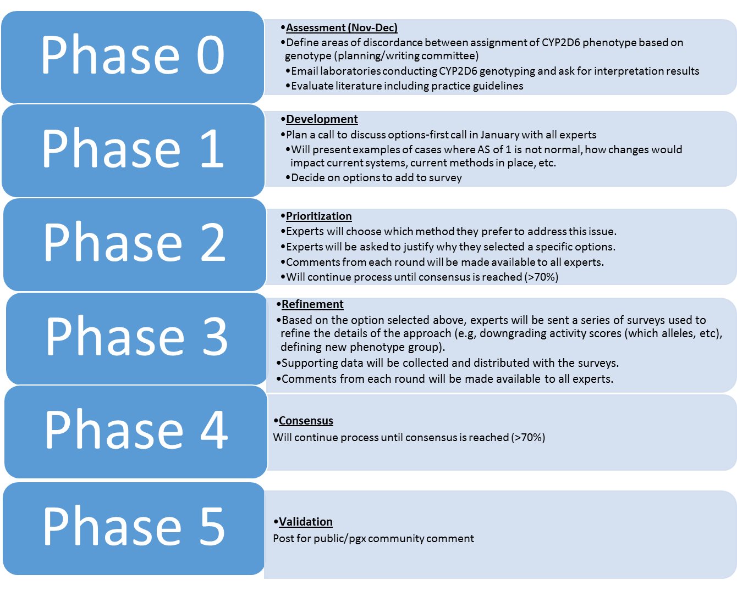

References
(1) AmpliChip™ CYP450 Package Insert. (ed. I, R.D.) (2005).
(2) Crews, K.R. et al. Clinical Pharmacogenetics Implementation Consortium guidelines for cytochrome P450 2D6 genotype and codeine therapy: 2014 update. Clin Pharmacol Ther 95, 376-82 (2014).
(3) Hicks, J.K. et al. Clinical Pharmacogenetics Implementation Consortium (CPIC) Guideline for CYP2D6 and CYP2C19 Genotypes and Dosing of Selective Serotonin Reuptake Inhibitors. Clin Pharmacol Ther 98, 127-34 (2015).

