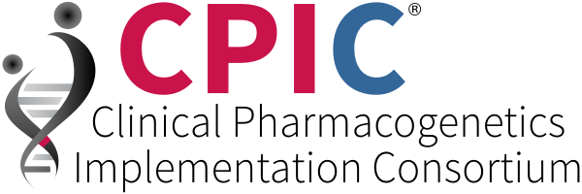
2019 Meeting, June 6th – 7th, 2019 Preliminary Program
St. Jude Children’s Research Hospital, Memphis, TN
Thursday, June 7th | Session title | Speakers
7:00AM – 8:00AM | Breakfast
8:00AM – 9:00AM | Grand Rounds: Implementation of Genomic Medicine | Marc Williams, MD
9:15AM – 10:15AM | Practical considerations for choosing a genetic testing platform and clinical lab | AMG’s recommendations for clinical genotyping allele selection-Vicky Pratt, Ph.D.  Quality metrics, CAP’s proficiency testing program for PGx testing – Gwen McMillin, Ph.D.  PharmCat-Michelle Whirl-Carrillo, Ph.D.
10:15AM – 11:00AM | Genotyping platforms panel discussion | TBD
11:00AM – 11:10AM | Coffee break
11:10AM – 12:00PM | Getting results to patients | 11:10-11:35 Risk and benefits of returning results directly to patients- Phil Empey, Pharm.D., Ph.D.  11:35-12:00 Electronic access via SmartCard – Henk-Jan Guchelaar, Pharm.D., Ph.D.
12:00PM – 1:00PM | Lunch | Dissemination Workgroup group meets  Informatics Workgroup group meets
1:00PM – 2:00PM | Navigating the EHR at different institutions with different vendors: the informatics and the implementer perspective on CPIC CDS | 1:00-1:30 Informatics-TBD  1:30-1:45 Cerner user-Gillian Bell, Pharm.D.  1:45-2:00 Epic user-Mark Dunnenberger, Pharm.D.
2:00PM – 3:00PM | Roundtable: Biggest and unanticipated challenges in CDS, EHR issues | TBD
3:00PM – 3:15PM | Coffee/snack break
3:15PM – 4:15PM | CPIC API/Database | Teri Klein, Ph.D.
4:15PM – 4:45 PM | Implementation/outcomes (codeine/tramadol) | Larisa Cavallari, Pharm.D.
4:45PM – 6:00PM | Poster session, wine & cheese, networking

Friday, June 7th | Session title | Speakers
7:00AM – 8:00AM | Breakfast
8:00AM – 8:45AM | Pgx in Psychiatry | Jeff Bishop, Pharm.D.
8:45AM – 11:15AM | “Hands on” program: From guideline to implementations Anatomy of evidence review as part of CPIC guideline development, Variant classification | Evidence review-Michelle Whirl-Carrillo, Ph.D./Kelly Caudle, Pharm.D  Consent/age of majority, pediatrics Patient education; Competencies/clinician education  -Cyrine Haidar, Pharm.D./Sara Van Driest, M.D., Ph.D.  Institutional drug policy issues: Integration with formulary/P&T, Safety metrics. Pharmacogenetic Oversight Committee-James Hoffman, Pharm.D.  Clinical informatics integration and challenges: Reporting, updating test results over time, CDS-Don Baker/ Sara Van Driest, M.D., Ph.D.  Data receipt, transfer, and QC issues-Nancy Kornegay, M.S.  Discussion about other resources that would be helpful for implementation
11:15AM – 11:30AM | Future of CPIC | Mary Relling, Pharm.D.

