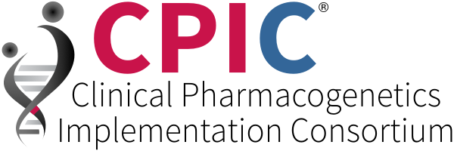
www.cpicpgx.org
SUMMARY: The Clinical Pharmacogenetics Implementation Consortium (CPIC®) www.cpicpgx.org is an international consortium of scientists and clinicians which facilitates the use of pharmacogenetic tests for patient care by creating freely available, peer-reviewed and evidence-based detailed gene/drug clinical practice guidelines following the rigorous Institute of Medicine’s standards for writing trustworthy clinical practice guidelines. CPIC works closely with multiple resources and other groups.
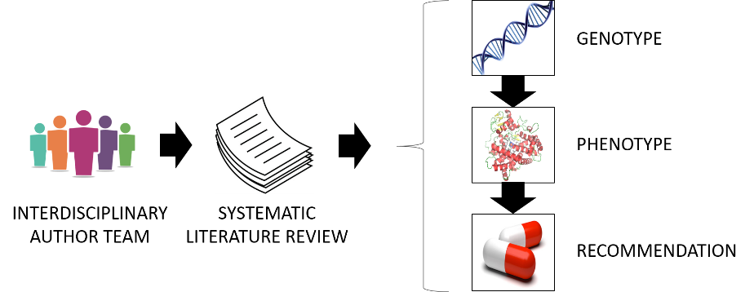
CPIC guidelines are designed to help clinicians understand HOW available genetic test results should be used to optimize drug therapy, assuming that genetic testing is becoming more widespread.
CPIC HIGHLIGHTS:
- Published in a leading journal (in partnership with Clinical Pharmacology and Therapeutics)
- Freely-available at cpicpgx.org
- Updated regularly
- Contain links to tables that can be used at clinical implementation sites to facilitate integration into electronic health care records
- Indexed in PubMed as clinical guidelines
- Endorsed/supported by professional societies (ASHP, ASCPT, CAP)
- Adheres to standard formats: standardized terms for allele function and phenotypes
- Has systems for grading levels of evidence, for assigning phenotypes to genotypes and assigning strengths to each prescribing recommendation
CPIC has a process for prioritizing CPIC guidelines. CPIC assigns actionability levels to gene/drug pairs. CPIC has monthly teleconferences, working groups, and provides resources for implementers. All of these resources are available at cpicpgx.org. All curated content published by CPIC is available under a creative commons public domain license; CPIC requests that users give attribution to CPIC.
An overview presentation is available at https://cpicpgx.org/resources/.
CPIC is funded by the NIH U24HG010135
Follow us @cpicpgx for news and updates

