Term Standardization for Clinical Pharmacogenetic alleles and phenotypes, Project II
A Project led by the Clinical Pharmacogenetics Implementation Consortium (CPIC)
10/09/2019
Background
In 2016, CPIC led a consensus effort to standardize terms for clinical pharmacogenetic tests. The goal of the project was to create standardized terms for pharmacogenetic allele function and phenotypes to be used in CPIC guidelines (specifically Tables 1 and 2) and in the larger pharmacogenetics community (1). However, additional standardization opportunities exist beyond the genes included in this project. For example, VKORC1 is a CPIC level A gene (https://cpicpgx.org/genes-drugs) on which we did not reach a consensus. This gene is tested primarily in the context of predicting starting doses of the common anticoagulant warfarin, which is also dependent on CYP2C9. Therefore, many laboratories report a drug-centered phenotype such as “greatly increased sensitivity to warfarin” (see the CPIC guideline for warfarin), which complicated standardization of VKORC1 terms following the formats used for other genes. Other genes such as RYR1, CACNA1S, CFTR, G6PD, IFNL3, and mtRNR1 (guideline in progress) have CPIC guidelines but standardized terms describing allele function and phenotype do not exist. In addition to these genes with CPIC guidelines, there are also genes without CPIC guidelines but are CPIC level A, B, or C genes that may need to be considered in the future such as GBA, NAGS, HPRT1, POLG, COMT, OPRM1, SCN1A, SLC6A4, F5 and urea cycle enzymes (ABL2, ASL, ASS1, CPS1, and OTC).
Project Purpose and Methods
The purpose of this project is to standardize additional terms that are used to characterize pharmacogenetic allele functional status and the presumed phenotype (generally based on diplotypes), and to encourage adoption by external groups (e.g., ClinGen, SNOMED, EHR vendors, clinical laboratories etc.). Standardizing these terms will facilitate computational generalizability of pharmacogenetic results and their interpretation and uptake in the health care system, as well as improve standardization of research resources.
It may not be possible to standardize these terms across all genes, and therefore, as part of this project, genes may need to be grouped into categories according to their characteristics. For example, a different approach may be needed for genes that effect efficacy versus toxicity versus where both efficacy and toxicity are affected. However, the goal is to use the minimum number of sets of terms to describe allele function and phenotypes.
The first step will be to establish a panel of experts (see below). To create standardized terms, the CPIC Informatics Working Group has devised the following plan: 1) review the literature and laboratory reports for genes in each of these groups and create a list of options for allele function and phenotype terms for CPIC genes; 2) using a modified Delphi method, survey experts to determine the best terms to use for each gene. Participation by experts will be solicited by direct emails and by posting an invitation to participate on the CPIC website and PharmGKB. The modified Delphi method is a structured approach to determine consensus through iterative surveys of an expert panel. Further details of the Delphi methods selected for this project are listed below. We expect at least 2 to 4 surveys of the expert panel will be required to achieve consensus. 3) Publish the results of the project. 4) Adopt these terms in future CPIC guidelines and facilitate their adoption by external groups.
Modified Delphi Method
The modified Delphi method to reach consensus is summarized below. Experts who volunteer to participate in the consensus process will be asked to complete each survey. We will be using a modified Delphi approach as outlined by Hsu, et al. (2) If it becomes difficult to achieve consensus across the expert panel by the fourth survey, survey responses will be ranked and the Kendall’s W statistic will be applied to facilitate final agreement. 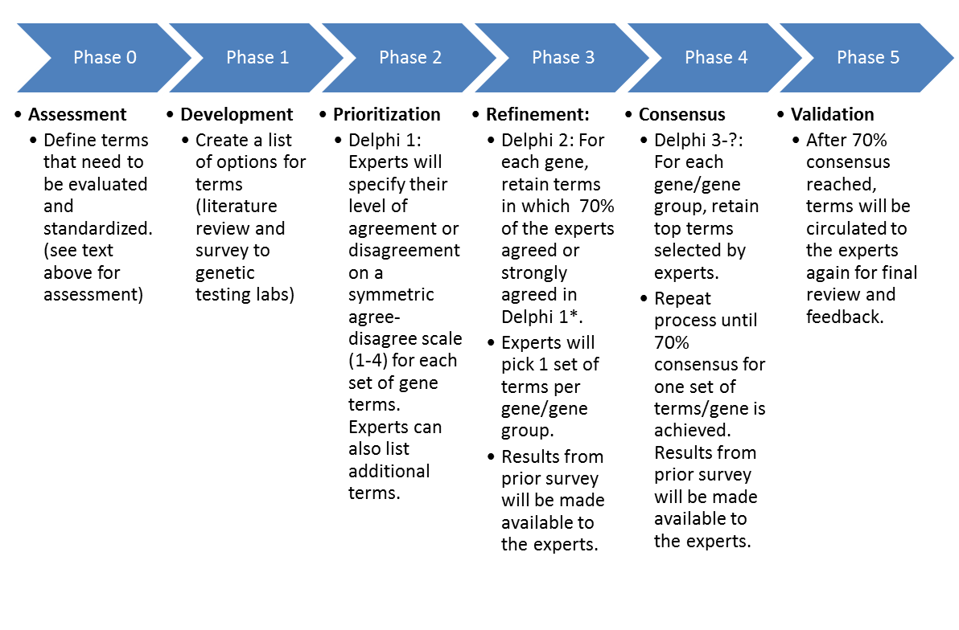
*If experts select the same term for genes with similar characteristics (e.g. CYP enzymes), these genes will be grouped together for subsequent surveys.
Implications of this project for CPIC and Others
We expect that terms will provide a framework for each guideline author group to use. However, the authors will continue to be responsible for assigning alleles and diplotypes relationships to the terms.
While the purpose of this project is to standardize terms used in CPIC guidelines, we expect these terms to have broad implications for the implementation of pharmacogenomics. As standardized nomenclature becomes part of the CPIC guidelines, broader use of these terms will develop with other organizations (e.g. clinical laboratories, SNOMED, LOINC, HL7, etc.).
Expert Panel
Experts will include members of CPIC, ClinGen, CDC PGx working group, Dutch Pharmacogenomics Working Group, PGRN, and others to determine the best terms to use for each gene. Participation by experts outside of these groups will be solicited by direct email invitations and posting an invitation to participate on the CPIC website and PharmGKB.
Expert Panel membership criteria:
  - Clinician with a working knowledge of pharmacogenetics (pharmacists, physicians, nurses, genetic counselors, etc).
  - Researcher with at least 2 years of PGx research experience
  - Clinical laboratory scientist or staff with at least 2 years of PGx experience
  - EHR standards expert/medical informatic (PGx experience not required but involvement in HL7 or similar experience preferred)
  - Gene specific experts and/or CPIC or DPWG guideline author for genes included in this project (i.e. RYR1, CACNA1S, CFTR, G6PD, IFNL3, mtRNR1 GBA, NAGS, HPRT1, POLG, COMT, OPRM1, SCN1A, SLC6A4, F5, ABL2, ASL, ASS1, CPS1, and OTC)

Authorship
As we expect to publish these results, authorship will be given to the subset of panel participants that substantially contribute to coordinating and drafting the surveys, reviewing the literature and laboratory reports for historical terms, and drafting the paper. The larger panel will be cited in an acknowledgement to any resulting publications. Similar to the CPIC guideline process a steering committee will be established that will act as the core authorship team.

(1) Caudle, K.E. et al. Standardizing terms for clinical pharmacogenetic test results: consensus terms from the Clinical Pharmacogenetics Implementation Consortium (CPIC). Genet Med 19, 215-23 (2017).
(2) Hsu, C.C. & Sandford, B.A. The Delphi Technique: Making Sense of Consensus. Practical Assessment, Research and Evaluation 12, 1-8 (2007).

