Term Standardization Part 2 proposal
Two expert panels will be created for each gene/drug guideline, a gene/disease expert panel and a PGx expert panel.
- Gene/Disease expert panel
  - CPIC guideline authors
  - Representation from other expert panels, if applicable
    - ClinGen Variant Curation Expert Panel
    - ClinVar
    - FDA
    - ACMG
    - CAP
    - AMP PGx working group
    - AACC
    - Other gene/disease specific resources (e.g., G6PD WHO working group, European Malignant Hyperthermia Group, etc)
  - Others as determined by guideline authors

- PGx expert panel
  - Clinician with a working knowledge of pharmacogenetics (pharmacists, physicians, nurses, genetic counselors, etc).
  - Researcher with at least 2 years of PGx research experience
  - Clinical laboratory scientist or staff with at least 2 years of PGx experience
  - EHR standards expert/medical informatic (PGx experience not required but involvement in HL7 or similar experience preferred)

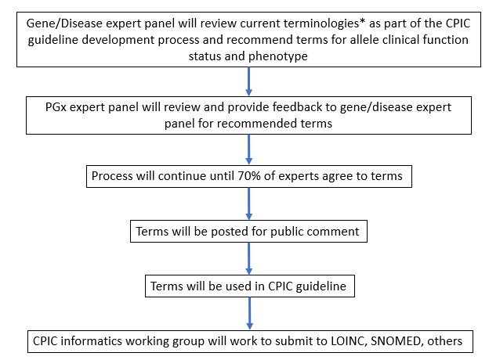
Process for consensus:

*Evaluation of current terminologies
- Gene/Disease expert panel will review all current terminology in the following resources:
  - ClinGen
  - ClinVar
  - FDA
  - ACMG
  - LOINC
  - SNOMED
  - Other gene/disease specific resources
  - Laboratory reports
- Guideline authors will utilize current terminology if/where appropriate. In some cases, disease terminology will not be appropriate if disease phenotype not 1:1 with drug phenotype (i.e. variants that are associated with disease risk are not all associated with drug phenotype and vice versa).

As we expect to publish these methods and the results for the first gene/drug, authorship will be given to the subset of panel participants that substantially contribute to coordinating and drafting the surveys, reviewing the literature and laboratory reports for historical terms, and drafting the paper. The PGx experts will be cited in an acknowledgement to any resulting publications. Similar to the CPIC guideline process a steering committee will be established that will act as the core authorship team.

