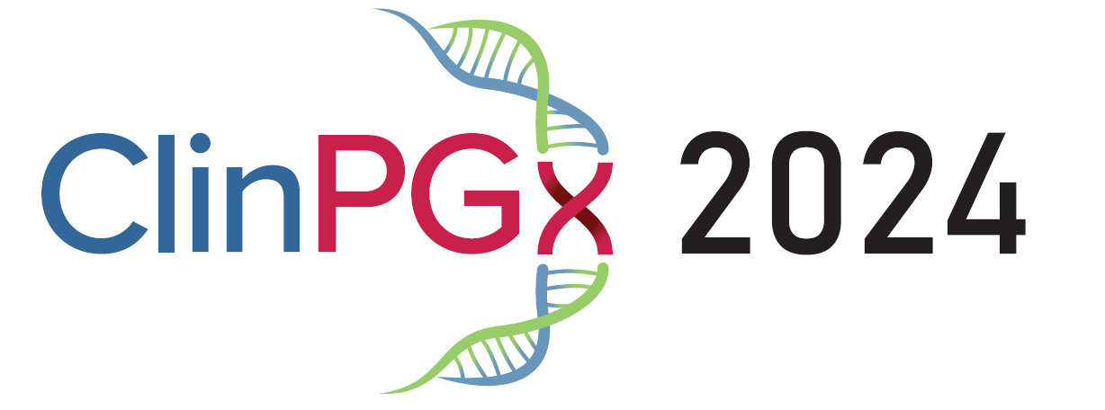
Knowledge, Implementation & Education
Meeting Agenda
June 20-21, 2024
University of Pennsylvania

June 20, 2024

7:45 – 8:45 Breakfast provided; Poster set-up

Opening Remarks (8:45am – 9:00am): Kelly Caudle, PharmD, PhD

Session 1 (9:00am – 10:30am): Why PGx (Justification as to why we are all here)
Moderator: Kelly Caudle, PharmD, PhD

9:00 – 9:30 Physician’s View: Stevens Johnson Syndrome
Teri Manolio, MD, PhD – National Human Genome Research Institute

9:30 – 10:00 Stevens Johnson Syndrome and Implementation of HLA testing
Sony Tuteja, PharmD, MS – Penn Center for Precision Medicine, University of Pennsylvania

10:00 – 10:30 Patient’s Representative view: Stevens Johnson Syndrome
Paul Anderson (father of Angela Anderson)

Session 2 (10:30am – 12:00pm): Implementation Strategies (Justification as to how we are doing this)
Moderator: TBD

10:30 – 10:50 VA National Pharmacogenomics Program: PGx Implementation in the Veterans Health Administration
Deepak Voora, MD – Durham Veterans Affairs Medical Center

10:50 – 11:10 Implementing CYP3A5 and tacrolimus
Amy L. Pasternak, PharmD– University of Michigan, College of Pharmacy

11:10 – 11:30 Implementation of Clinical Pharmacogenomics Across a Multi-State Health System
Natasha Petry, PharmD, MPH– Sanford Health Imagenetics

11:30 – 12:00 State of the art with clinical labs and implementers: A Panel Discussion
Kristine Crews, PharmD – St. Jude Children’s Research Hospital
Others TBD

12:00 – 1:30 Lunch provided including time for networking; Poster set-up

Session 3 (1:30pm – 3:00): Regulatory Hurdles and the path forward
Moderator: TBD

1:30 – 1:55 Legislation Efforts in Pharmacogenomics
Kristine Ashcraft, BS, MBA– YouScript

1:55 – 2:20 Challenges and Opportunities in Regulating Pharmacogenomics
Don Rule – Translational Software

2:20 – 2:35 The All of Us Experience
Phil Empey, PharmD, PhD – University of Pittsburgh

2:35 – 3:00 Regulatory Hurdles and the path forward: How do we move forward?
Moderated Discussion led by TBD

3:00 – 3:30 Networking/Bathroom break

Session 4 (3:30-5:00): PGx Resources
Moderator: Marylyn Ritchie, PhD

3:30 – 3:50 Pharmacogenomics Knowledgebase (PharmGKB) and Pharmacogenomics Clinical Annotation Tool (PharmCAT)
Michelle Whirl-Carrillo, PhD – Stanford University

3:50 – 4:10 Clinical Pharmacogenetics Implementation Consortium (CPIC)
Kelly Caudle, PharmD, PhD – St. Jude Children’s Research Hospital

4:10 – 4:30 PGx Resources: PharmVar - new content and features
Andrea Gaedigk, PhD – Children’s Mercy Research Institute

4:30 – 5:00 Clinical Pharmacogenomics (ClinPGx) and Clinical Genome Resource (ClinGen)
Teri Klein, PhD – Stanford University

5:00 – 6:30 Posters and Happy Hour
6:30 – onwards Dinner on own

June 21, 2024

8:00 – 9:00 Breakfast provided

Session 4 (9:00am – 10:30am): Use of AI and LLMs to Improve Precision Health
Moderator: Teri Klein, PhD

9:00 – 9:30 Leveraging Electronic Health Record Data for Targeted Detection of Cognitive Impairment
Kyra O'Brien, MD – Penn Memory Center, University of Pennsylvania

9:30 – 10:00 AI & Oncology
David Penberthy, MD, University of Virgina

10:00 – 10:30 Explainable AI for health: Where We Are and How to Move Forward
Su-In Lee, Ph.D., University of Washington

Session 5 (10:30am – 12:00pm): Advancing Pharmacogenomics Education Across the Spectrum of Clinician Training
Moderator: TBD

10:30 – 11:00 Beginning at the Beginning : Preparing Students in Pharmacy and Medical Schools to Become Leaders in Pharmacogenomics
Kristin Wiisanen, PharmD - Rosalind Franklin University of Medicine and Science

11:00 – 11:30 Equipping Residents and Fellows to Deliver the Future of Precision Medicine
Kristine R. Crews, PharmD – St. Jude Children’s Research Hospital

11:30 – 12:00 Improving the Genomic Literacy of Healthcare Professionals Through the Inter-Society Coordinating Committee for Practitioner Education in Genomics (ISCC-PEG)
Roseann S. Donnelly, PharmD, FCCP, BCPS- Massachusetts College of Pharmacy and Health Sciences

12:00 – 1:00 Boxed Lunch provided including time for networking

Session 6 (1:00pm – 2:00pm): Recent Developments from the Clinical Labs, EPIC Brain Trust & Closing
Moderator: TBD

1:00 – 1:20 AMP’s Recommendations for Clinical Pharmacogenotyping Allele Selection
Victoria M. Pratt, Ph.D., FACMG- Indiana University School of Medicine

1:20 – 1:40 Development of in-house PGx testing at Children's Mercy
Laura Ramsey, PhD – Children’s Mercy

1:40 – 2:00 Collaborations with Epic on PGx and Closing Remarks
Marylyn Ritchie, PhD – University of Pennsylvania School of Medicine

