Clinical Functional Assignment of NAT2 Star Alleles by the Clinical Pharmacogenetics Implementation Consortium Pharmacogene Curation Expert Panel – Supplemental Materials

Table of Contents
Supplemental Methods 2
Inclusion of Alleles 2
Evaluation of Evidence 2
Allele Frequency 3
Figure S1. NAT2 Allele Nomenclature Survey Process and Results 4
Figure S2. Systematic Literature Review 6
Table S1. Assignment of Allele Clinical Function and Strength of Evidence 6
Table S2. Functional Assignment to Alleles 8
Table S3. NAT2 Nomenclature Survey 9

Supplemental Methods

Inclusion of Alleles
Prior to the transfer to PharmVar in March 2024, NAT2 gene nomenclature was maintained and updated by the NAT Gene Nomenclature Committee. PharmVar utilizes NG_012246.1 RefSeq as the NAT2 reference sequence which corresponds to the legacy allele, NAT2*12A, now referred to as NAT2*1. The former reference sequence, X14672.1 (PMID: 7773298), differs from NG_012246.1 at coding position c.803; where X14672.1 has “A”, NG_012246.1 has “G”. This change caused variant switching to occur for several NAT2 alleles and altered their allele definitions. All NAT2 alleles within PharmVar are defined by core SNVs, with sub-alleles containing additional variants that do not alter protein function. In this regard, historical NAT2 sub-families have been reclassified to better align with the star allele nomenclature (i.e., NAT2*5A and *5D are now NAT2*16). Similarly, alleles which are characterized by multiple functional SNVs have been given new star allele designations to account for potentially unique functions arising from the combinations of multiple variants within the same allele. For example, NAT2*30 (formerly NAT2*5E) is characterized by c.341T>C (p.I114T), c.590G>A (p.R197Q), and c.803G>A (p.R268K). The migration of NAT2 allele nomenclature to PharmVar aids in the standardization of allele functional terms and diplotype-to-phenotype assignments that will ultimately enhance the clinical implementation of NAT2 pharmacogenetic test results.

Evaluation of Evidence
The NAT2 PCEP primarily utilized two types of evidence: in vitro studies of NAT2 enzymatic activity and clinical genotype-to-phenotype concordance studies. In vitro studies assess NAT2 allele function through exogenous expression of variants in a variety of cell systems, including bacterial, yeast, and mammalian cells. Enzymatic activity is measured using cellular lysates or purified protein incubated with co-factors (i.e. acetyl-CoA) and substrates of interest. Sulfamethazine, 2-aminofluorene, 4-aminobiphenyl, and procainamide are commonly used as substrates for in vitro reactions (7669073, 8081359, 11337936, 15564878, 17264801, 17434923, 28523442, 33815485). Typically, in vitro studies assess the function of individual SNVs, although some studies express full haplotypes containing multiple SNVs.
NAT2 phenotyping is often conducted using caffeine or sulfonamides (including sulfamethazine, sulfasalazine, and dapsone) as probe drugs. Within the caffeine metabolic pathway, NAT2 N-acetylates paraxanthine (1,7-Dimethylxanthine) to produce 5-acetylamino-6-formylamino-3-methyluracil (AFMU). Thus, phenotyping studies using caffeine commonly measure urinary or plasma concentrations of AFMU, 1-methylxanthine (1X), and 1-methyluric acid (1U) to determine NAT2 activity, in which activity is reported as the ratio of these metabolites (most often either AFMU/1X or AFMU/AFMU+1X+1U, though other variations exist). Despite its widespread use as a probe drug in early clinical studies, caffeine is a suboptimal substrate for assessing NAT2 acetylation activity as caffeine is metabolized by several enzymes, including many members of the cytochrome P450 family, which are also highly polymorphic (17221922, 22293536). The use of sulfonamides as probe drugs allows for more accurate determination of NAT2 acetylation activity as NAT2 directly acetylates these compounds and activity can be measured using the ratio of acetylated substrate to parent compound in urine or plasma. More specifically, derivatives of sulfasalazine are acetylated by both NAT1 and NAT2; however, sulfamethazine is selective for NAT2 (24892773), making sulfamethazine a better option for phenotyping studies among this group of compounds. Additional publications assess NAT2 phenotype using more medically relevant substrates, such as isoniazid or hydralazine.

Allele Frequency
The most common NAT2 variant alleles are NAT2*4, NAT2*5, NAT2*6, NAT2*7, and NAT2*14 [Ref frequency table]. However, the frequency of NAT2 variant alleles varies widely by population (21494681, 37023111). While all populations exhibit a bimodal distribution of NAT2 phenotype, the ratio of rapid to poor metabolizers varies by region. The majority of individuals in Asian populations are phenotypically rapid metabolizers, while Europe, Africa and the Middle East have a higher prevalence of poor metabolizers (37023111). Genotypically, the NAT2 SNVs c.191G>A, c.341T>C, c.590G>A, and c.857G>A account for a large proportion of decreased function alleles [Ref allele functionality table] and each contributes to the prevalence of poor metabolizers in different populations worldwide. Specifically, c.191G>A is present in 10% of African and American populations, but is very rare in Asian and European populations; c.341T>C is present in 50% of Europeans and c.857G>A is present in 20% of individuals with East Asian ancestry (33094670); c.590G>A is most common in European populations, but is also prevalent in the Americas and Asia (37023111). Collectively, the global distribution of NAT2 variant alleles highlights the contribution of NAT2 polymorphisms to the distribution of NAT2 phenotypes observed in different populations.

Figure S1. NAT2 Allele Nomenclature Survey Process and Results
(A)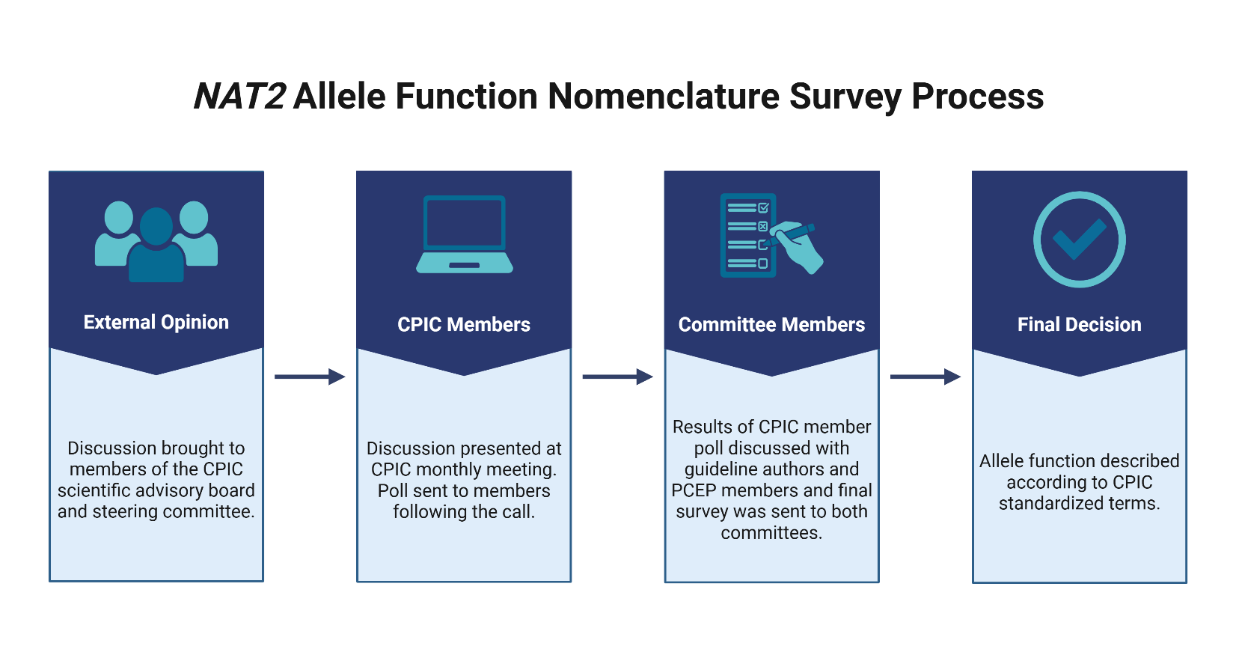 (B)
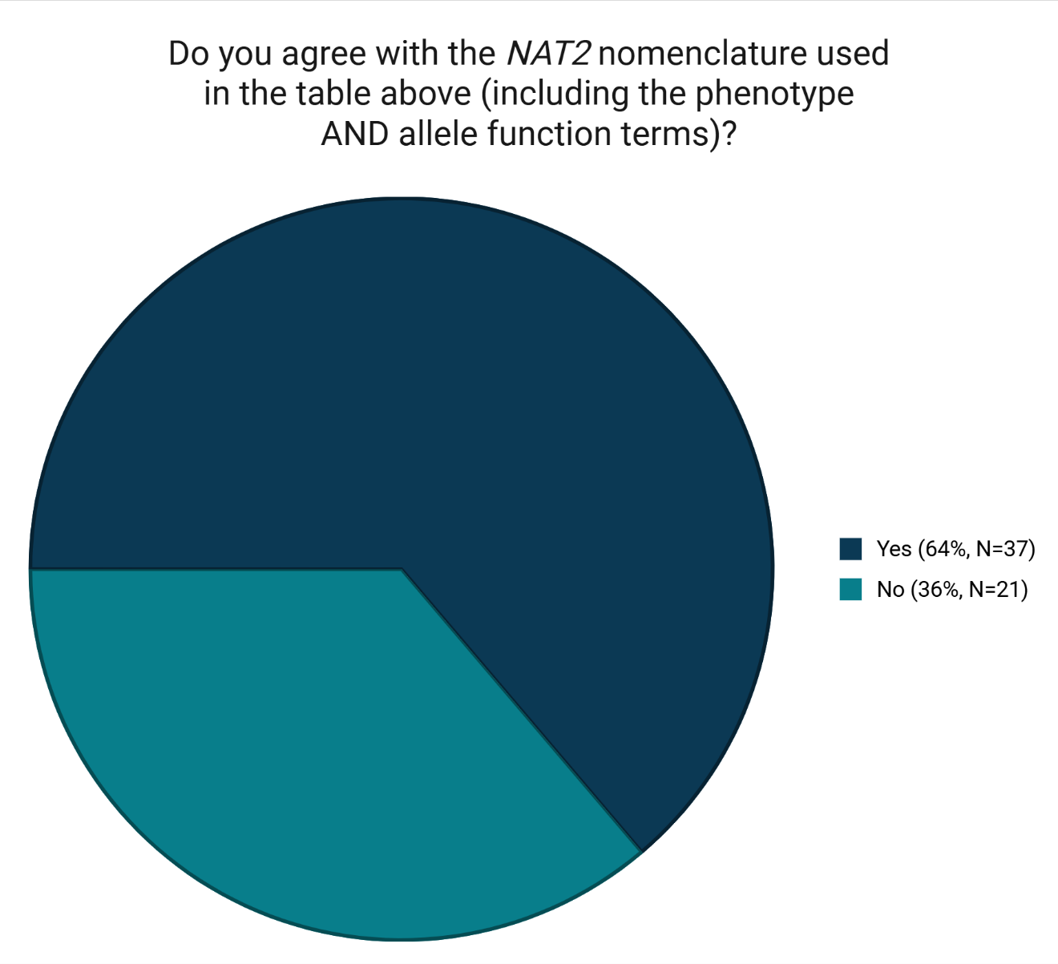
(C)
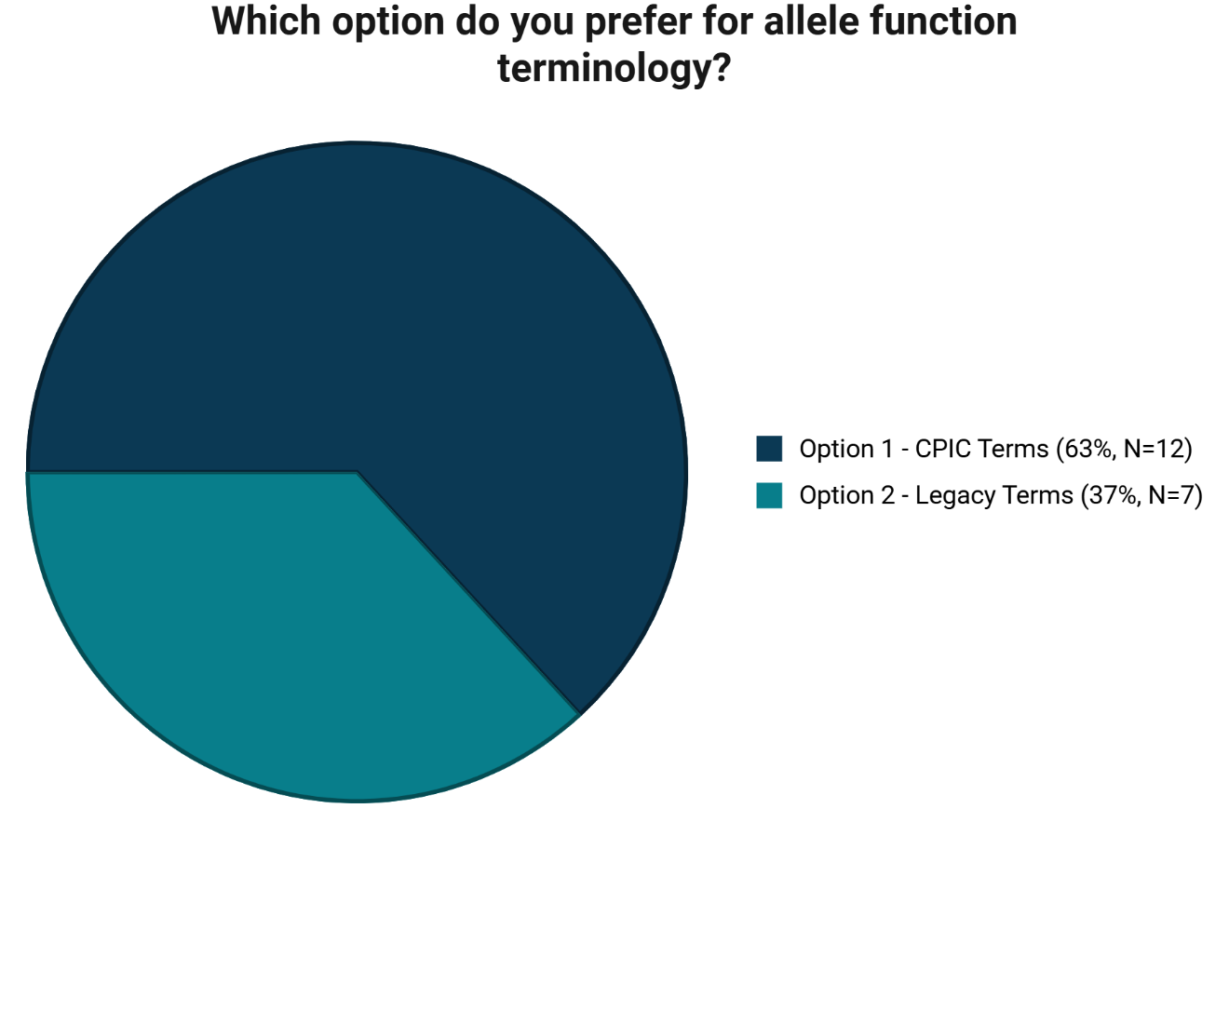
Figure S1. (A) In response to concerns raised by the NAT2 PCEP and guideline author committee regarding the application of CPIC standardized terminology to NAT2 phenotype and allele function, NAT2 allele function nomenclature was evaluated using a structured process. (B) Results of CPIC member survey. The survey sent to CPIC members included the phenotype table as it is presented in the main text (Table 2) which corresponds to option 1 in Table S4. (C) Results of PCEP member and guideline author survey.

Figure S2. Systematic Literature Review
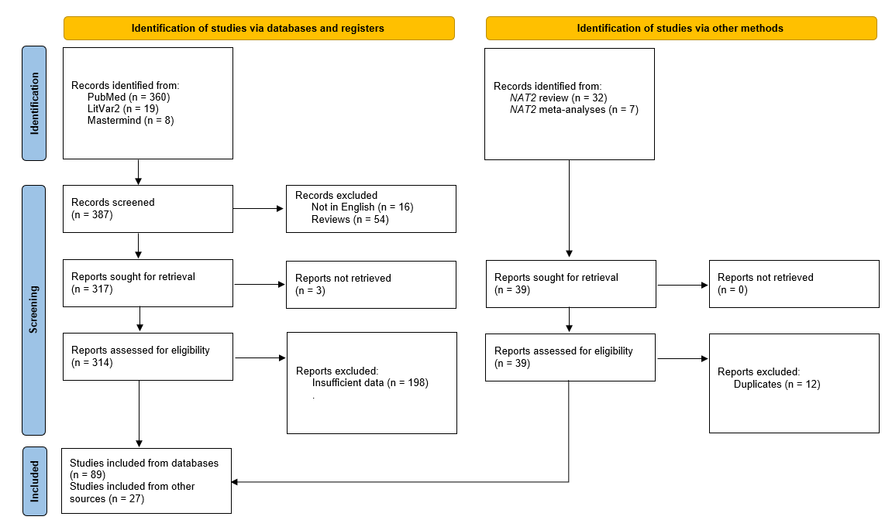
Figure S2. PRISMA 2020 flow diagram of systematic literature review conducted for NAT2 polymorphisms.

Table S1. Assignment of Allele Clinical Function and Strength of Evidence
Strength of Evidence | Evidence Criteria | Examples
DEFINITIVE | The causal role of this allele in this particular drug phenotype has been repeatedly demonstrated in independent clinical studies and has been upheld over time. No convincing, adequately powered evidence has emerged that contradicts the role of the allele in the noted drug phenotype.  For NAT2, function of a single variant has been heavily studied over the last 25+ years and is well-established. | NAT2*5, NAT2*6, NAT2*7, NAT2*14
STRONG | There is strong evidence to support a causal role for this allele in this drug phenotype, including at least two independent clinical studies providing evidence for the allele’s role in drug phenotype in addition to at least one of the following types of evidence:  • Case reports  • In vitro data (e.g. experimental data comparing the consequences of introducing the variant, or correlative data showing concordance of genotype with phenotype) support the variant-drug phenotype association  • Computational activity predictions overall support in vivo and/or in vitro data (25741868)  AND no convincing, adequately powered evidence has emerged that contradicts the role of the allele in the noted drug phenotype.
MODERATE | There is moderate evidence to support a causal role for this allele in this drug phenotype, including at least two of the following types of independent evidence:  • At least 2 patient cases demonstrating drug phenotype causality  • In vitro experimental data (e.g. engineered variant and effect measures support the variant-drug phenotype association)  • At least one clinical study providing evidence for the allele’s role in drug phenotype  AND no convincing, adequately powered evidence has emerged that contradicts the role of the allele in the noted drug phenotype.  For NAT2:  Alleles characterized by two or more variants with well-established function.  Alleles characterized by one variant with well-established function and one with concordant computational evidence to predict function. | NAT2*15, NAT2*29, NAT2*33, NAT2*50
LIMITED | There is limited evidence to support a causal role for this allele in this drug phenotype, including at least two independent studies based on the following types of evidence:  • A case report  • In vitro data (e.g. experimental or correlative data) support the variant-drug phenotype association  • Computational activity predictions overall support in vivo and/or in vitro data (25741868)  Computational activity predictions may be sufficient in unequivocal cases of early stop codon or complete gene deletions.  AND no convincing, adequately powered evidence has emerged that contradicts the role of the allele in the noted drug phenotype.  Function assignment based on limited data should only be made for genes whose resulting drug phenotype dictates changes to prescribing that are much more likely to result in improved clinical outcomes than not changing prescribing based on genetic test results, including consideration of life-threatening consequences if not considered.  For NAT2:  Alleles characterized by one variant with well-established function and one variant with unknown or uncertain function, particularly where computational evidence was conflicting. | NAT2*19, NAT2*47, NAT2*48
INADEQUATE – Uncertain Function | Fewer than 2 patient cases with no convincing in vitro experimental data, with extremely limited or conflicting in vitro data.  This designation should be used when the evidence is not sufficiently strong to support a clinical functional status that can inform prescribing actionability.  For NAT2:  Alleles characterized by variants with conflicting in vitro and computational evidence.  Alleles characterized by variants with insufficient evidence, as stated above. | NAT2*10, NAT2*21, NAT2*27
NO EVIDENCE – Unknown Function | There is no literature describing function. | NAT2*55, NAT2*60, NAT2*61

Table S2. Functional Assignment to Alleles
Term/Gene Category | Allele Functional Term* | Functional Definition | Considerations for diplotype/phenotype that may inform functional assignments | Example
Allele Clinical Functional Status-pharmacogenes based on drug metabolizing enzymes | Increased Function | Rapid acetylation function | When both alleles have increased function, the acetylator phenotype of the patient is increased relative to intermediate or poor metabolizers warranting different categorization (e.g. “rapid metabolizer”). For NAT2 there is no “normal metabolizer” phenotype owing to the distribution of NAT2 acetylation activity globally. | NAT2*4
 | Decreased Function | Slow acetylation function | When patients are homozygous for decreased function alleles, or when patients have one decreased function allele and one increased function allele, the phenotype of such a person is different compared to a patient who is homozygous for increased function alleles. | NAT2*5  NAT2*14
 | Unknown Function | No literature describing function, or the allele is novel | N/A | NAT2*55  NAT2*60
 | Uncertain Function | Literature supporting function is insufficient, conflicting, or weak | N/A | NAT2*10  NAT2*27

Table S3. NAT2 Nomenclature Survey
CPIC terms predicted phenotype | Acetylator Phenotype | Option 1 – CPIC Terms | Option 2 – Legacy terms | Examples of NAT2 diplotypes
NAT2 rapid metabolizer (RM) | Rapid acetylator | An individual carrying two increased function alleles | An individual carrying two rapid function alleles | *1/*4, *4/*4
NAT2 intermediate metabolizer (IM) | Intermediate acetylator | An individual carrying one increased function allele and one decreased function allele | An individual carrying one rapid function allele and one slow function allele | *1/*5, *4/*6
NAT2 poor metabolizer (PM) | Slow acetylator | An individual carrying two decreased function alleles | An individual carrying two slow function alleles | *5/*5, *5/*6
NAT2 indeterminate | NA | An individual carrying one or two uncertain or unknown function alleles | An individual carrying one or two uncertain or unknown function alleles
Table S3. Response options for NAT2 nomenclature survey to PCEP members and guideline authors. Note that the CPIC member survey included only Option 1 for consideration. Terms that were in question are highlighted in red font.

